977-401 Digital Engineering Project II
Semester 1/2026

Augmented Intelligent using Image Processing and LLM: A Case Study of Patient Triage System
Project Report

Phokin Wanna 6630613024

Advisor: Aj.Wisarut Chantara

__________________________

Asst.Prof. Dr.Komsan Kanjanasit
Asst.Prof. Kullawat Chaowanawatee

College of Computing
Prince of Songkla University, Phuket Campus
Project Title Augmented Intelligent using Image Processing
and LLM: A Case Study of Patient Triage System

Author Phokin Wanna 6630613024
Major Digital Engineering
Academic Year 2026

Abstract
This project was the development of a contactless patient triage Assistant, which utilizes multiple algorithms combined with image processing. For this system is designed for helping to reduce overcrowding in the emergency department and triage area or Outpatient Department.
The system consists of three main modules:
- Vision Module that using Image Processing, algorithms and Neural Networks, specifically Convolutional Neural Networks (CNNs). To detect or classify pain gestures and physically anomaly.
- Audio Module to transcribe Thai and English spoken symptoms into text via STT (Speech-to-Text) and TTS (Text-to-Speech) models.
- Processing Module to deploy a local large language model to combine a visual and an auditory data for decision making and sent out the feedback.
The expected result of this project was a real time kiosk system. That it can classify patients into ESI levels, detect important physical signs and assist nurses by generating clinical summaries and visual evidence to reducing workload of nurses.
Keywords: Patient triage, Image processing, convolutional neural network, TensorFlow, large language models and Emergency severity index

Acknowledgements
In this project has been completed successfully and mostly would like to thank adviser, Aj.Wisarut Chantara. For his helping direction support during the research and development process.
I would also like to thank my peers in the nursing faculty for providing necessary requirements and insights of the medical triage worksflow.

Phokin Wanna
28 September 2026
TABLE OF CONTENTS

Abstract ii
Acknowledgements iii
List of Figures vi
List of Tables vii
List of Abbreviations viii
Chapter 1 Introduction 10
  - Overview 10
  - Objectives 10
  - Scope 11
  - Procedures 11
  - Expected Project Results 12
  - Locations 13
  - Development Tools 13
Chapter 2 Theory Background / Literature Review 14
  - Large Language Models (LLM) & Edge Quantization 14
    - Transformer Architecture & Contextual Understanding 14
    - 4-Bit Parameter Quantization 14
    - Prompt Engineering & Output Schema Constraining 14
  - Emergency Severity Index (ESI) Triage Standard 15
  - Computer Vision & Pose Topology 18
    - OpenCV 18
    - MediaPipe Framework and Pose Topology 18
  - Deep Learning for Facial Distress Analysis 19
    - Limitations of Manual Color Thresholding (HSV) 19
    - Convolutional Neural Networks (CNNs) 19
    - Edge Model Optimization with TensorFlow Lite 20
TABLE OF CONTENTS (CONT.)

  - Automatic Speech Recognition (ASR) 21
  - Multi-Core Concurrency & Parallel Processing 21
    - Process and Thread Concurrency 21
    - Asynchronous Producer-Consumer Architecture 21
  - Related Research 21
Chapter 3 Methodology & System Architecture 23
  - System Architecture 23
    - Offline Training and Model Optimization Pipeline 23
    - On-System Kiosk Inference Pipeline 23
    - CNN Architecture Specification 24
  - System Design & Operational Workflows 25
    - Kiosk System Workflow 25
    - Audio & Dialogue Subsystem Workflow 25
    - Vision Subsystem Workflow 25
    - Clinical Handoff & Nurse Dashboard Workflow 25
  - System Implementation 27
    - Computer Vision: Pose Geometry & Dynamic Disambiguation 27
    - Facial Perfusion & CNN Classification (CIELAB Color Space) 28
    - Clinical Reasoning Engine (Local LLM Integration) 30
  - System Integration, Concurrency & Security 30
    - Concurrency & Producer-Consumer Queues 30
    - Integrity Data Governance & PDPA Compliance 30
    - Nurse Dashboard Web Application & Database Integration 30
  - Project Plan 36
Chapter 4 Results and Conclusion 37

  - Summary of Preliminary Prototype (Project DE I Baseline) 37
    - Overview and Baseline Objectives 37
TABLE OF CONTENTS (CONT.)

    - Preliminary Subsystem Performance and Benchmarks 37
    - Limitations and Work Improvement 39
  - Skin Color Classification and CNN Model Results 40
    - Skin Extraction Results 40
    - CNN Model Architecture 45
    - Quantitative Model Results: Cross Entropy Loss & Focal Loss 45
    - Analysis of Model 01: Cross Entropy Loss (CEL) 45
    - Analysis of Model 02: Binary Focal Loss (FL) 45
    - Improvement Roadmap 45
  - Vision Subsystem: Gesture and Posture Recognition Results 48
    - Dynamic Mapping & Temporal Logic 48
    - Target Distress Postures 48
    - False-Positive Suppression (Benign Filters) 48
    - Empirical Benchmark & Error Analysis (70 Trials) 48
  - Results of Kiosk Workflow and Evaluation 51
    - System Initialization and Pre-Warming 51
    - Autonomous Patient Intake and State Transition Results 52
    - Summary 52
  - Conclusion 53
  - Future Work 53
References 54

LIST OF FIGURES

Figure 2-1 General Model of LLMs 14
Figure 2-2 LLM Architected 14
Figure 2-3 ESI Triage Algorithm v4 15
Figure 2-4 OpenCV 16
Figure 2-5 MediaPipe 16
Figure 2-6 Convolutional Neural Network Concept 23
Figure 2-7 TensorFlow Lite 25
Figure 3-1 System Architecture 28
Figure 3-2 Kiosk System Workflow 30
Figure 3-3 Audio System Workflow 32
Figure 3-4 Vision System Workflow 35
Figure 3-5 Clinical Handoff and Nurse Dashboard Workflow 37
Figure 3-6 Clinical JSON Output Format 38
Figure 4-1 Testing Vision: Thinking 39
Figure 4-2 Testing Vision: Crossed Arms 40
Figure 4-3 Testing Vision: Chest Pain Posture 41
Figure 4-4 Testing Vision: Red Face Detected 41
Figure 4-5 Facial Skin Segmentation and Head-Pose Adaptation 42
Figure 4-6 Confusion Matrix of Model 01 (CEL) 42
Figure 4-7 Performance Metrics of Model 01 (CEL) 43
Figure 4-8 ROC Curve of Model 01 (CEL) on Holdout Test Set 43
Figure 4-9 Training Convergence and Performance for Model 02 (FL) 44
Figure 4-10 Kiosk Workflow System Tested (1) 44
Figure 4-11 Kiosk Workflow System Tested (2) 45
Figure 4-12 Kiosk Workflow System Tested (3) 46
Figure 4-13 Log of Kiosk Workflow System Tested 46
Figure 4-14 Example of Json files outcome after finishing a case 47

LIST OF TABLES
Table 3-1 CNN Layer Architectural Specifications 31
Table 3-2 Project I plan 31
Table 3-3 Project II plan 31
Table 4-1 Limitations and Work Improvement 4
Table 4-2 Layer Breakdown of the CIELAB-Skin-CNN Architecture 4
Table 4-3 Comparative Performance Matrix Across Experimental Models 4

 | LIST OF ABBREVIATIONS
ESI  gTTS | Emergency Severity Index  Google Text-to-Speech
JSON | JavaScript Object Notation
LLM  NLP | Large Language Model  Natural language processing
OPD | Outpatient Department
PDPA | Personal Data Protection Act
ROI | Region of Interest
SOAP | Subjective Objective Assessment Plan
STT | Speech-to-Text
TTS | Text-to-Speech
CNN | convolutional neural network
ASR | Automatic Speech Recognition

Chapter 1 Introduction

This chapter covers the background, objectives, scope, methodologies, expected project outcomes, as well as the location and tools used for system development.

Overview
Hospital congestion is rarely caused by trauma cases alone most crowding happens right at the front lobby and Outpatient Department (OPD). Around 80 to 90% of patients are general walk-ins seeking routine care and nurses spend hours every day asking the same repetitive medical history questions. At the same time, nurses must stay on high alert because severe or time sensitive emergencies like silent heart attacks or strokes, can walk into the general waiting area unnoticed.
This project proposes a Contactless Patient Triage Assistant. Placed at hospital entrance points and screening areas. This kiosk screens patients without physical contact by combining computer vision, speech recognition and a local Large Language Model (LLM). The system adapts its interview based on urgency:
- For critical cases: If catches visual pain’s signs or skin distress before or in between conversation, skips lengthy questioning to ask only essential details and immediately alerts nurses.
- For stable cases: It conducts a routine medical history interview in Thai or English and drafts a clinical summary, taking the repetitive documentation burden off nursing staff while keeping emergency safeguards in place.

Objective
1.2.1 Detect acute pain postures (chest, head, abdomen) and to classify abnormal facial redness or flushing.
1.2.2 Deploy a local LLM to evaluate urgency using ESI standards, asking concise questions for emergencies while handling full history interviews for stable patients.
1.2.3 Assist nurses by provide a triage summaries or SOAP notes and visual evidence.

Scope

1.3.1 Target Users & Setting
- Placement: Hospital lobbies, OPD screening points, and triage waiting areas.
- Target Patients: Conscious adult walk-in or wheelchair patients standing or sitting 1.0 - 1.5 meters from the kiosk.
- Exclusions: Unconscious patients (sent straight to resuscitation), stretcher or bedridden patients, and pediatric cases.

1.3.2 Technical Scope
- Hardware: 1080p webcam, build-in microphone and an Apple M1 Mac with 7 core GPU and 8GB Unified Memory.
- MediaPipe joint tracking, CNN for facial skin classification and 4-bit Llama 3.2 for clinical reasoning.
- On device execution in RAM with no cloud uploads. Provide a structured JSON payload contains automated SOAP draft and photo evidence to the nurse's screen over LAN.

Procedures
Step 1: Nurse Interviews
- Interview nursing students, to understand triage workflows.
Step 2: Vision Module Development
- Built MediaPipe geometric logic for pain poses
- Trained a custom CNN for facial redness or flushing detection.
Step 3: Audio & Logic Development
- Implement Speech Recognition for bilingual (Thai and English) speech-to-text processing.
- Fixing the Llama 3.2’s parameter.
- Integrate TTS (Text-to-Speech) for automated bilingual voice response generation.
Step 4: System Optimization
- Rebuilt the backend into a 4-core parallel architecture and quantized the LLM to 4-bit.
Step 5: Testing & Evaluation
- Tested the kiosk using simulated patient cases ranging from critical conditions to mild illnesses.
- Then evaluate classification accuracy and response time process.
Step 6: Deployment
- Built a local web interface and Provide a Json file that it must contain patient info and ESI level.
Step 7: Final Documentation
- Complete the report, documentation and evaluation results.

Expected Project Results
- Identify ESI levels and detects physical distress cues (posture, facial flushing).
- Cut intake time from several minutes to under 30 seconds by generating SOAP notes.
- Can handle critical emergencies while automating routine questions for stable walk-in patients.
- Provide a reliable and complete offline system environment that protects patient privacy under PDPA laws.

Locations
- College of Computing, Prince of Songkhla University, Phuket Campus.

Development Tools
Software
- Programming Language: Python 3.10+
- AI & Vision Frameworks: MediaPipe, TensorFlow & TensorFlow Lite, SpeechRecognition, Fast Whisper, gTTS, Ollama (Llama 3.2)
- Interface: Streamlit / HTML, CSS, JavaScript
Hardware
- Apple M1 Mac (8-core CPU, 7-core GPU, 8GB Unified Memory).
- Built-in 1080p webcam and microphone.

Chapter 2 Theory Background/Literature Review

An overview of the fundamental theoretical and principles that used as the foundation for this project.

Large Language Models (LLM) & Edge Quantization

2.1.1 Transformer Architecture & Contextual Understanding
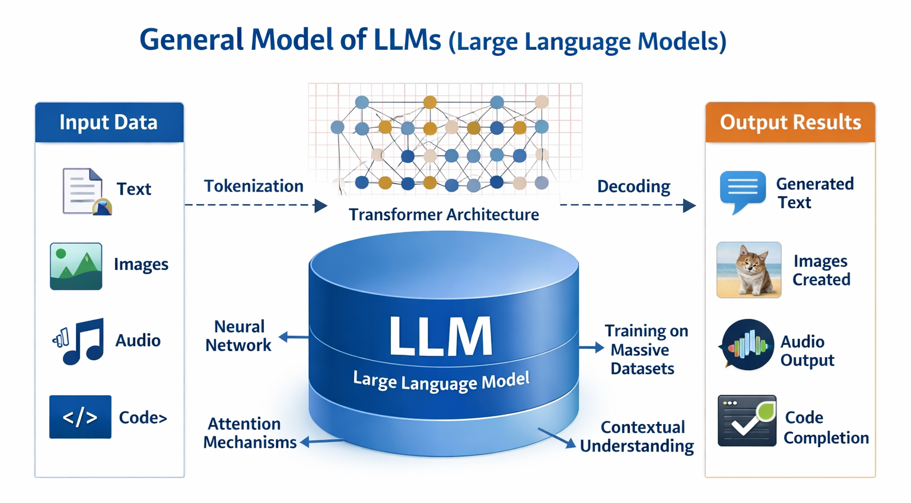

Figure 2-1 General Model of LLMs
A large language model (LLM) [1] is an artificial intelligence (AI) system that designed to understand and generate human language. Unlike older rule-based natural language processing (NLP) models that search for rigid keywords, modern LLMs are built on the Transformer architecture.
It was the Mechanism within the transformer architecture [2]. This mechanism allows the model to weigh the relevance of different words in a sentence simultaneously, rather than processing them sequentially. The input text will break down into numerical pieces that were "tokens” which calculates mathematical relationships between all words in a sentence simultaneously. And The model then applies to understand the semantic relationships between these tokens. Incorporate techniques Grouped Query Attention (GQA) and parameter quantization.

2.1.2 4-Bit Parameter Quantization
Deploying an LLM directly on edge hardware, such as an Apple M1 Mac with 8GB of Unified Memory that is creates a major memory bottleneck. In standard 16-bit floating-point format, models like Llama 3.2 require roughly 5.5 to 6.0 GB of memory. In an 8GB system, this leaves almost no memory for the operating system, camera feeds, MediaPipe or CNN inference that leading to memory swapping and unacceptably high latency (~27.2 seconds per response).
To make edge execution viable, the system applies 4-bit post-training quantization using the local Ollama runtime, drawing on quantization principles [3] established:
- Quantization compresses the model’s weight representations from 16 bits down to 4 bits.
- This reduces the active model footprint from ~6 GB down to ~2 GB, preserving over 70% of memory for the vision and audio threads.
- Running across the Apple M1's unified high-bandwidth memory, token generation speed improves dramatically, reducing total inference time from 27.2 seconds down to 5.8 seconds without degrading conversational triage reasoning.

2.1.3 Prompt Engineering & Output Schema Constraining
In a medical setting, generative language models must not produce verbose conversational text or hallucinate unverified medical conditions.
To ensure deterministic, clinically reliable behavior. This project uses structured prompt constraints:
- The system prompt restricts the model to a pre-triage assistant tasked solely with assessing urgency via the Emergency Severity Index (ESI Version 4). Definitive medical diagnosis is explicitly barred.
- Visual pain flags and transcribed speech are formatted as key-value pairs before entering the prompt.
- The model is constrained to return only a valid JSON payload containing specific keys contain ESI level, Clinical summary, Action needed, and SOAP note. This guarantees the output can be parsed programmatically and rendered instantly onto the Nurse Dashboard.

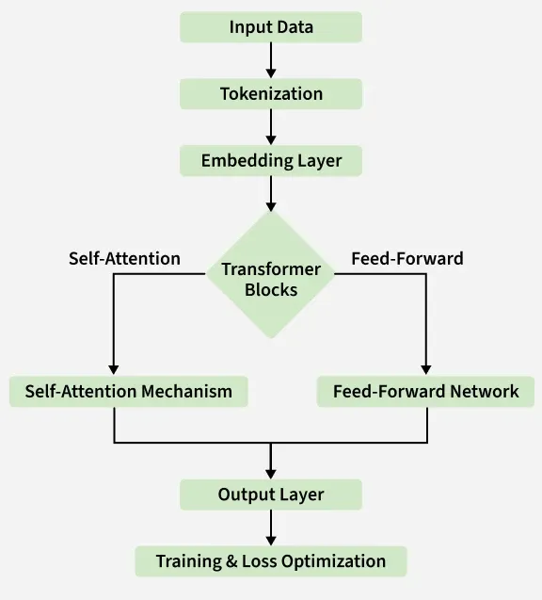

Figure 2-2 LLM Architected

Emergency Severity Index (ESI) Triage Standard [4]
This project references the Emergency Severity Index (ESI) Version 4, developed by the Agency for Healthcare Research and Quality (AHRQ) in USA. This standard provides as the Core Logic for the Large Language Model to evaluate patient urgency and categorizing them into five levels as follows:
- Level 1 (Resuscitation)
  - Definition: A patient with a life threatening condition, that needs help right away. Without immediate medical treatment, the patient is at high risk of dying.
  - Symptom: Uunconscious or have stopped breathing or are gasping for air or are experiencing heart failure or severe shock.
- Level 2 (Emergent)
  - Definition: Is in a high risk situation, experiencing severe pain (between 7 - 10), or showing with acute confusion. Treatment must be start within 10 - 15 minutes.
  - Symptom: Severe chest pain, unilateral weakness, suspected stroke or severe dyspnea.
- Level 3 (Urgent)
  - Definition: Has stable vital signs but requires "two or more evidence" for evaluation and treatment. Treatment should begin within 30-60 minutes.
  - Symptom: Severe abdominal pain and closed fractures requiring X-rays and splinting or high fever with dyspnea, etc.
- Level 4 (Less Urgent)
  - Definition: Has stable vital signs and is expected to require "only one evidence" for evaluation and treatment.
  - Symptom: Minor lacerations, sprained ankle, or suspected urinary tract infection (UTI).
- Level 5 (non urgent)
  - Definition: General patients seeking treatment for minor illnesses. Require no resources beyond a standard physical examination and a medical prescription.
  - Symptom: Common cold, sore throat, minor rashes, prescription refills or routine wound dressing.

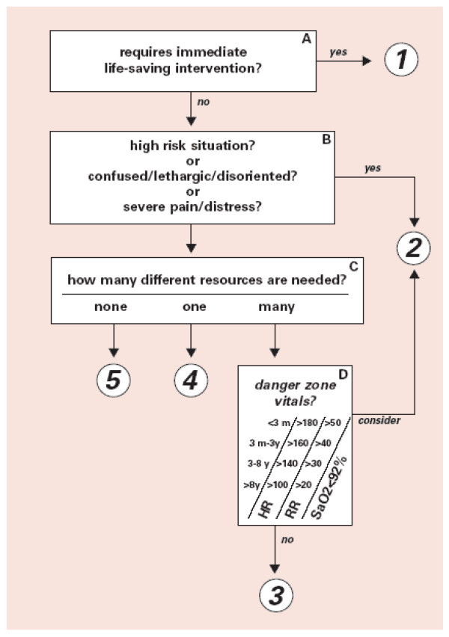

Figure 2-3 ESI Triage Algorithm v4 [3]

Computer Vision & Pose Topology
Computer vision is a subfield of artificial intelligence that enables computers to derive high-level understanding from digital images or videos.

2.3.1 OpenCV [5]
OpenCV is a highly optimized open source programming library designed specifically for real time computer vision and machine learning applications.
- OpenCV processes images as multi-dimensional matrices. It applies linear algebra and matrix operations to alter these pixels. For instance, it can convert a standard RGB matrix into a different color space such as HSV or apply a mathematical threshold to isolate specific regions of an image for further analysis.


Figure 2-4 OpenCV

2.3.2 MediaPipe Framework and Pose Topology
MediaPipe is an open-source framework developed by Google for building cross-platform, customizable machine learning pipelines for time-series data, such as video streams.
- MediaPipe Pose utilizes a machine learning architecture called BlazePose. The pipeline first uses a detector to locate the human region within the frame, and then a subsequent landmark model predicts the exact (x, y, z) coordinates of the 33 anatomical joints. These spatial coordinates can then be used to calculate anatomical angles and distances using standard Euclidean geometry and trigonometry, allowing for precise human action and gesture recognition.


Figure 2-5 MediaPipe

Deep Learning for Facial Distress Analysis
Physiological vision analysis is the process of using optical camera sensors to detect subtle changes in human skin color and perfusion that correlate with cardiovascular and autonomic nervous system responses. In medical triage, changes in facial perfusion specifically pallor (paleness from circulatory shock) or flushing (redness from high fever or hypertensive crisis) must provide vital diagnostic evidence of acute patient distress.

2.4.1 Limitations of Manual Color Thresholding (HSV)
The HSV (Hue, Saturation, Value) color space is a cylindrical color representation that models color in terms of its dominant wavelength (Hue), purity (Saturation), and brightness (Value). Traditional image processing often uses HSV to isolate color shades from illumination changes.
In initial system testing, manual HSV thresholding achieved only 56% accuracy. In real hospital lobbies, fluctuating ambient fluorescent lighting, shadows, and screen backlights from the kiosk monitor directly reflect off the patient’s face. Because Hue and Saturation are mathematically coupled to maximum and minimum RGB channel values, external screen glare distorts the calculated saturation, causing false-positive pallor detections on healthy patients.

2.4.2 Convolutional Neural Networks (CNNs) [6]
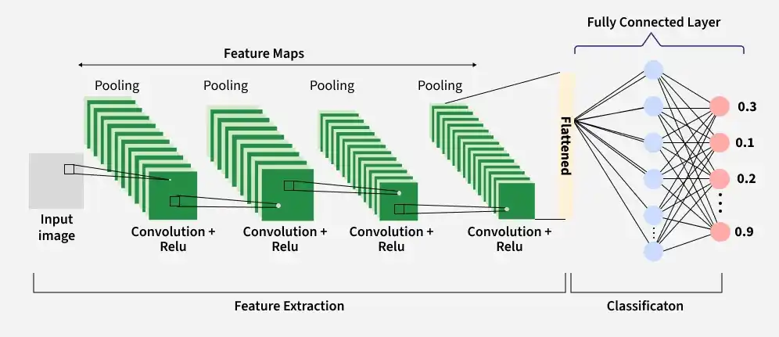
Convolutional Neural Networks are very similar to ordinary Neural Networks from the previous chapter: they are made up of neurons that have learnable weights and biases. Each neuron receives some inputs, performs a dot product and optionally follows it with a non-linearity. The whole network still expresses a single differentiable score function: from the raw image pixels on one end to class scores at the other. And they still have a loss function (e.g. SVM/Softmax) on the last (fully-connected) layer and all the tips/tricks we developed for learning regular Neural Networks still apply. Unlike traditional fully connected networks that flatten images into 1D vectors and lose spatial structure, CNNs preserve spatial relationships between adjacent pixels.
Figure 2-6 convolutional neural network concept
A standard CNNs architecture consists of three primary functional layers:
- The fundamental building block that slides small parameter matrices (kernels or filters, such as 3 x 3) across the input image. By computing dot products between the kernel and localized receptive fields, the layer generates Feature Maps that detect low-level edges, textures, and localized color gradients.
- Introduces non-linearity into the network using the Rectified Linear Unit
$ReLU (x) = max(0, x)$ (2-1)
allowing the network to learn complex non-linear clinical boundaries while preventing vanishing gradient issues during backpropagation.
- Reduces the spatial dimensions (width and height) of feature maps using operations like Max Pooling. This down-sampling minimizes computational overhead, controls overfitting, and grants translation invariance (the ability to recognize a pattern regardless of its exact position in the frame).
- Fully Connected (Dense) & Output Layer: Flattens the final pooled feature maps into a vector and applies an activation function (such as Softmax for multi-class classification or Sigmoid for binary classification) to output a probability distribution across target clinical classes.

2.4.3 Edge Model Optimization with TensorFlow Lite

TensorFlow is an open-source platform developed by Google for designing, training, and deploying scalable machine learning models [7]. TensorFlow Lite (TFLite) is its specialized, lightweight execution environment tailored for executing trained models on mobile, embedded and edge computing devices.
Figure 2-5 TensorFlow Lite

2.5 Automatic Speech Recognition (ASR) [8]
Automatic Speech Recognition (ASR) is a computational technology that enables the recognition and translation of spoken language into text. Modern ASR systems, such as the Whisper model that use deep learning and Transformer architectures to process audio signals.
- An ASR system takes a raw audio waveform as its input, analyzes the acoustic and linguistic properties of the sound, and generates a corresponding written transcript

2.6 Multi-Core Concurrency & Parallel Processing [9]
Parallel processing is a computational technique where multiple tasks execute simultaneously across separate processor cores to prevent resource-heavy jobs from blocking time-critical I/O operations.

2.6.1 Process and Thread Concurrency
In modern operating systems, a thread is the smallest schedulable unit of CPU execution within a process. In a single-threaded program, heavy computational tasks like LLM generation cause the entire application to pause, freezing video streams and dropping audio frames. By partitioning independent tasks across separate threads, multi-core processors maintain continuous sensor polling and interface updates while background neural networks compute inference.

2.6.1 Asynchronous Producer-Consumer Architecture
The Producer-Consumer pattern is an architectural design where producer threads generate data into shared buffers and consumer threads independently process that data. In this kiosk, high-frequency sensory tasks (30 fps camera frames and 16 kHz audio) are decoupled from slower reasoning tasks using thread-safe non-blocking FIFO queues. This asynchronous execution eliminates UI freezing and delivered a 96% speedup in system responsiveness on multi-core hardware.

2.7 Related Research
2.7.1 " Designing Effective User Interface Experiences for a Self-Service Kiosk to Reduce Emergency Department Crowding " [10]
- Medical kiosks are physical station, that it deployed in hospital waiting areas. The it integrated with biometric sensors
- Systems require patients to physically interaction, with the machine to measure signs and manually input their complaints by a touchscreen
2.7.2 " Contactless Patient Care Using Hospital IoT: CCTV Camera Based Physiological Monitoring in ICU " [11]
- In computer vision have to numerous studies on non-contact patient monitoring systems, in intensive care units (ICUs) and emergency ward
- They are using RGB and thermal cameras to extract physiological signals. And detect pain levels through facial expression analysis and posture estimation algorithms
2.7.3 "Large language models in medicine." [12]
- There is a growing body of research on the application of LLMs in healthcare for clinical note generation and patient interaction
- Modern systems transcribe patient-doctor conversations and generate structured clinical summaries using powerful cloud-based APIs
- Cloud based LLMs give significant data privacy (PDPA/HIPAA) and latency challenges in emergency medical settings. by using a locally deployed. This ensures complete data privacy while simultaneously fusing auditory data with real time visual metadata to make safety critical triage decisions
The proposed a Contactless Patient Triage Assistant, makes the limitations of existing solutions. First, unlike traditional kiosks, it is completely contactless, reducing infection risks and physical strain on critical patients. Second, it achieves multimodal combination by cross verifying visual physiological anomalies with verbal symptoms in real time and surpassing single domain AI tools. Finally, by deploying the LLM reasoning module locally on local hardware. The system ensures strict PDPA compliance. That was eliminating the privacy risks associated with cloud based LLM.

Chapter 3 Methodology & System Architecture

This chapter presents the architectural framework, design principles, mathematical logic and implementation details of this project. Developed specifically for emergency department intake and Outpatient Department (OPD) screening points, the system executes multimodal artificial intelligence models such as CNN and LLM entirely on edge computing hardware to deliver real time triage evaluations under strict data privacy regulations.

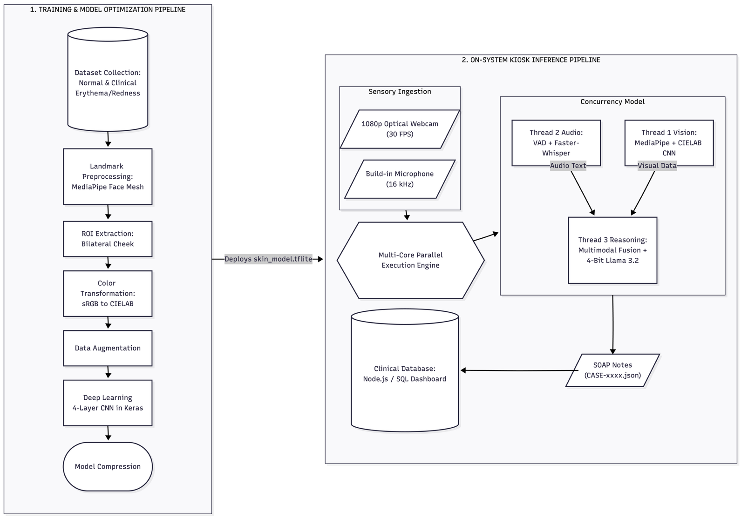
System Architectures
Figure 3-1 System Architecture
The proposed system employs an edge-native, multimodal pipeline that captures, synchronizes and evaluates visual physical indicators and conversational acoustic speech concurrently. To ensure methodological clarity and satisfy engineering standards for machine learning systems, the architecture is partitioned into two distinct operational pipelines:
- Training and Model Optimization Pipeline: Governs data collection, color space preprocessing, CNN feature learning, and edge quantization for facial distress detection.
- On-System Kiosk Inference Pipeline: Governs live sensory capture, asynchronous multithreaded processing, heuristic geometric disambiguation, LLM clinical reasoning and automated nurse station dispatch.

Offline Training and Model Optimization Pipeline

The offline pipeline trains and compresses the deep learning model that detects acute facial flushing (erythema). Facial flushing serves as a vital diagnostic cue indicating physiological distress, such as hyperthermia, high fever, or hypertensive crisis.

- Dataset Acquisition and Preparation
- A balanced dataset of facial images was compiled, incorporating diverse skin phototypes (Fitzpatrick scales I–VI) in both normal resting states and documented clinical/simulated erythema states.
- Dataset samples were curated under varying illumination angles and background conditions to build resilience against ambient hospital lighting variations.
- Automated ROI Segmentation via Facial Landmarks
- Rather than processing entire facial frames. Which introduce background clutter and non-skin artifacts such as hair, sclera and oral cavities. And the pipeline uses Google MediaPipe Face Mesh.
- Three facial landmark anchors are tracked per side: the inner ocular canthus, the alar base of the nose, and the auricular tragus.
- The centroid of these coordinates defines the center of a dynamic bounding box ($64×64$ pixels) that isolates the smooth malar cheek surface.

- CIELAB Color Space Transformation & Channel Extraction
- The extracted RGB pixel matrices are mapped to the device independent CIELAB ($L^{*}a^{*}b^{*}$) color space.
- Because the $L^{*}$ component represents luminance and is mathematically decoupled from the chromatic channels, the $a^{*}$ axis (which quantifies position along the green and red continuum) directly isolates blood perfusion changes and capillary dilation.
- Contrast normalization and color jitter augmentations are applied to enhance chromatic boundaries along the $a^{*}$ dimension.

- CNN Architecture Design & Training
- A dedicated four-layer Convolutional Neural Network (CNN) is designed to operate on the preprocessed CIELAB feature patches.
- The architecture uses alternating $3×3$ convolutional filters with Rectified Linear Unit (ReLU) activation functions, Batch Normalization and Max Pooling ($2×2$) layers to extract hierarchical chromatic and texture features.
- A Dropout layer ($p=0.3$) precedes the fully connected dense layers to prevent overfitting.
- The output layer employs a Softmax activation function to compute posterior class probabilities:
$\overset{ˆ}{y}=\text{Softmax}\left(W_{d}⋅f+b_{d}\right)$ (3-1)

classifying patches into ${\text{Class}}_{0}$ (Normal Perfusion) or ${\text{Class}}_{1}$ (Acute Flushing/Erythema).
- Model Compression via TensorFlow Lite (TFLite)
- To enable real-time inference on edge hardware without competing for memory bandwidth against the vision and LLM threads, the trained Keras model (.keras) is compiled into a TensorFlow Lite (.tflite) FlatBuffer.
- Post-training quantization optimizes weights into a compact binary file under 2.5 MB, achieving sub-10ms inference latencies on edge CPU cores.

On-System Kiosk Inference Pipeline
The online pipeline represents the operational system deployed on the physical kiosk, coordinating hardware input streams. Includes parallel feature extraction, generative reasoning and clinical data handoff in real time:
- Sensory Ingestion Layer
- Visual Stream: A 1080p webcam captures 30 fps video of the patient from a 1.0 - 1.5m operating distance.
- Acoustic Stream: A microphone array records 16 kHz audio, utilizing Voice Activity Detection (VAD) to isolate patient speech from background noise.
- Parallel Multithreaded Processing Layer
- Vision Engine: Tracks skeletal landmarks via MediaPipe BlazePose to detect acute pain clutching across the chest, cranium, and abdomen. Simultaneously, it extracts facial landmarks, converts the cheek ROI to CIELAB space, and runs a quantized TFLite CNN to classify normal facial pigmentation and flushing.
- Audio Engine: Processes active speech using Faster-Whisper (Int8 quantized via CTranslate2) to transcribe bilingual (Thai/English) clinical symptoms into text.
- Asynchronous Coordination Layer
- Utilizes a thread FIFO queues to decouple sensory streams from slower computational processes. A central coordinator manages session states, temporal pain timers and dialogue turns without dropping video frames.
- Clinical Reasoning Layers
- Triggered by dialoguse completion or visual distress alerts, the system compiles visual metadata and transcripts into an ESI Version 4 prompt. A local 4-bit Llama 3.2 model (via Ollama) outputs a structured JSON payload containing the assigned ESI level (1–5), clinical justification, and a draft SOAP note.

- Clinical Output & Dispatch Layer
- Delivers instructions via pre-recorded .mp3 templates or dynamic gTTS audio playback.
- Writes the finalized JSON case record to a network spool, which a Node.js web server and SQL database instantly ingest and render on the triage workstation.

CNN Architecture Specification
- Input Tensor Formulation
The input to the network is a cropped malar cheek patch extracted via
MediaPipe Face Mesh landmark triangulation. The patch is standardized to:
$X∈R^{64×64×3}$ (3-2)
where the spatial dimensions are $64 ×64$ pixels, and the 3 channels represent the CIELAB ($L^{*}a^{*}b^{*}$) color space. Prior to ingestion, channel values are normalized:
$L_{\text{norm}}^{*}=\frac{L^{*}}{100.0}, a_{\text{norm}}^{*}=\frac{a^{*}+128.0}{255.0}, b_{\text{norm}}^{*}=\frac{b^{*}+128.0}{255.0}$ (3-3)
This maps all inputs to the range $\left[0,1\right]$, stabilizing gradient descent during backpropagation.
- CNNs Layer Architectural
The network employs a sequential in 4 stage convolutional hierarchy designed to capture localized chromatic gradients along the $a^{*}$ axis while maintaining low memory consumption.
Table 3-1 CNN Layer Architectural Specifications
Layer Index | Layer Type | Kernel \ Filter Config | Stride & Padding | Output Tensor Shape | Activ-ations | Trainable Parameters
0 | Input Layer | - | - | $$\left(64,64,3\right)$$ | - | $$0$$
1a | Conv2D-1 | $$16\text{ filters }\left(3×3\right)$$ | Stride 1, Same | $$\left(64,64,16\right)$$ | ReLU | $$\left(3×3×3+1\right)×16=448$$
1b | Batch Normalization | - | Momentum 0.99 | $$\left(64,64,16\right)$$ | - | $$16×4=64$$
1c | MaxPooling2D-1 | Pool size $\left(2×2\right)$ | Stride 2 | $$\left(32,32,16\right)$$ | - | $$0$$
2a | Conv2D-2 | $$32\text{ filters }\left(3×3\right)$$ | Stride 1, Same | $$\left(32,32,32\right)$$ | ReLU | $$\left(3×3×16+1\right)×32=4,640$$
2b | Batch Normalization | - | Momentum 0.99 | $$\left(32,32,32\right)$$ | - | $$32×4=128$$
2c | MaxPooling2D-2 | Pool size $\left(2×2\right)$ | Stride 2 | $$\left(16,16,32\right)$$ | - | $$0$$
3a | Conv2D-3 | $$64\text{ filters }\left(3×3\right)$$ | Stride 1, Same | $$\left(16,16,64\right)$$ | ReLU | $$\left(3×3×32+1\right)×64=18,496$$
3b | Batch Normalization | - | Momentum 0.99 | $$\left(16,16,64\right)$$ | - | $$64×4=256$$
3c | MaxPooling2D-3 | Pool size $\left(2×2\right)$ | Stride 2 | $$\left(8,8,64\right)$$ | - | $$0$$
4 | Flatten | - | - | $$\left(4096\right)$$ | - | $$0$$
5a | Dense (FC) | $$64\text{ units}$$ | - | $$\left(64\right)$$ | ReLU | $$\left(4096+1\right)×64=262,208$$
5b | Dropout | Rate $p = 0.3$ | - | $$\left(64\right)$$ | - | $$0$$
6 | Dense (Output) | $$2\text{ units}$$ | - | $$\left(2\right)$$ | Softmax | $$\left(64+1\right)×2=130$$
Total | - | - | - | - | - | 286,370 Parameters (~1.1 MB FP32)

- Mathematical Parameter Calculation Formula
$\text{K-Width = Kernel Width }$, $\text{K-Height = Kernel Height}$, (3-4), (3-5)
$\text{NF = N}umber of Filters$ (3-6)
${\text{Parameters}}_{\text{Conv}}=\left(\text{K-Width}×\text{K-Height}×\text{Input Channels}+1_{\text{bias}}\right)×\text{NF}$ (3-7)
${\text{Parameters}}_{\text{Dense}}=\left(\text{Input Neurons}+1_{\text{bias}}\right)×\text{Output Neurons}$ (3-8)
- Mathematical Parameter Calculation Formula
Loss Function: Focal Loss (to address potential class imbalance by reduce weighting easily classified patches)
$L_{Focal}=-\sum_{k=1}^{K}{α_{k}{\left(1-\hat{y_{k}}\right)}^{γ}}y_{k}\log\left(\hat{y_{k}}\right), K=2$ (3-9)
where $γ= 2.0$ is the focusing parameter and $α_{k}$ represents the balancing weight for each class.
- Optimization Algorithm:
Adam ($α= 0.001$, $β_{1}=0.9$, $β_{2}=0.999$, $ϵ={10}^{-7}$) (3-10)
- Batch Normalization after each convolution stabilizes internal covariate shift, Dropout ($p = 0.3$) prevents co-adaptation of features on localized skin patches.
- Quantized to an INT8 FlatBuffer for reducing model size to ~290 KB (with inference latency under 6 ms on the Apple M1 neural engine).

System Design & Operational Workflows
The operational design describes the end-to-end user journey and subsystem-level interaction sequences that govern patient screening, non-contact tracking, reasoning and nursing handoff.

Kiosk System Workflow
The kiosk operates as a contactless station placed in the hospital lobby or triage waiting area. The assessment executes through five consecutive phases:
Phase 1: Detection & PDPA Consent
- As the patient steps into the calibrated zone (1.0 to 1.5 meters from the kiosk), the camera detects human presence.
- The system plays an automated bilingual voice prompt explaining that non-contact video and audio are being analyzed for pre-triage assessment in accordance with Thailand's PDPA regulations.
- If the patient steps away or verbalizes refusal, the session aborts cleanly. Upon affirmative consent then the kiosk proceeds.
Phase 2: Individualized Baseline Calibration (0–3 Seconds):
- During the first 3.0 seconds ($t≤3.0\text{s}$), the system records baseline physiological and geometric references:
  - Skin Perfusion Baseline is a averages the chromaticity values ($Baseline_{a^{*}}$, $Baseline_{b^{*}}$) from the cheek ROI to account for natural skin pigmentation differences.
  - Body Scale Baseline is a measures bi-acromial shoulder width and torso height to dynamically scale distance thresholds.
Phase 3: Concurrent Non-Contact Sensing & Dialogue
- The Vision Engine continuously monitors 33 skeletal joints and facial ROIs at 30 fps.
- The Audio Engine initiates structured symptom intake via pre-recorded audio prompts.
- Emergency Fast-Track Interruption is If the patient exhibits acute chest-clutching for $≥2.0$ seconds (suggesting acute coronary syndrome) or severe facial flushing, the system will immediately bypass routine questions, initiates an emergent handoff and then alert to the nurses.
- 3-Strike Clinical Rule is If the patient provides three consecutive irrelevant, confused, or uninterpretable answers, the dialogue engine treats this as an indicator of Altered Mental Status (acute disorientation) under ESI Level 2, then playing an urgent alert and flagging the case immediately.

Phase 4: Multimodal Clinical Reasoning
- Visual distress indicators and transcribed dialogue are synthesized into a structured ESI Version 4 prompt.
- The 4-bit quantized Llama 3.2 model evaluates symptom urgency, cross-checking physical signs against verbal complaints.

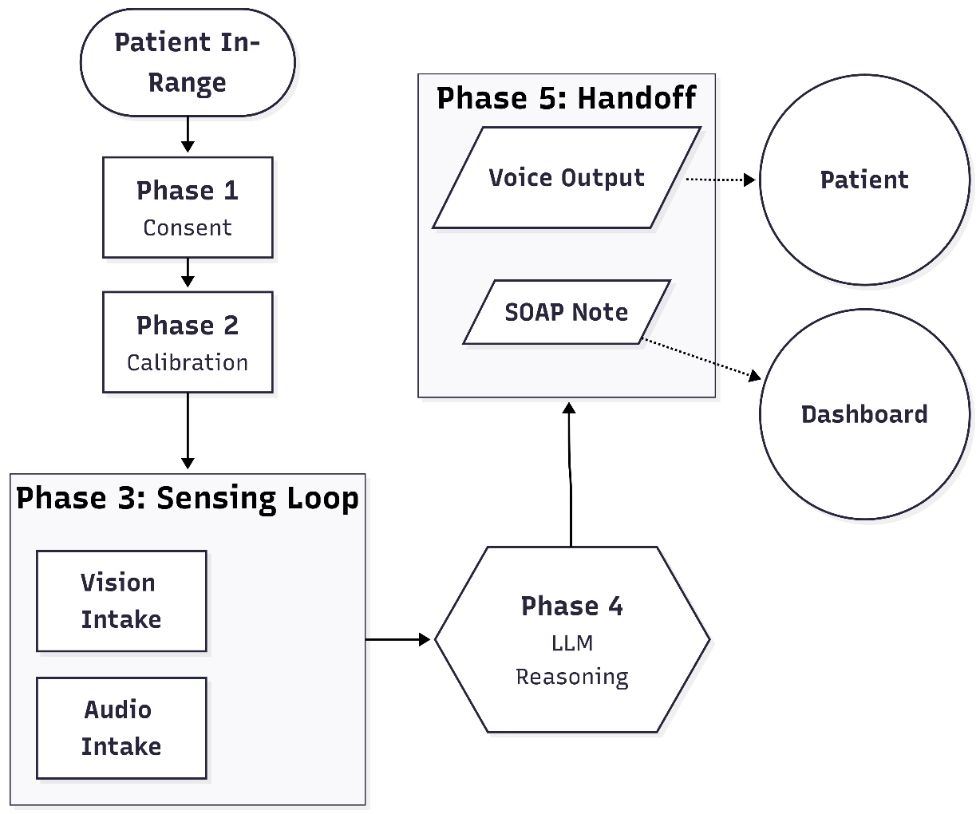
Figure 3-2 Kiosk System Workflow

Audio & Dialogue Subsystem Workflow
The Audio Subsystem manages conversational intake in noisy waiting room environments:
- Continuously monitors 16 kHz acoustic frames and isolating active patient speech from ambient hospital noise.
- Passes detected speech segments to Faster-Whisper (CTranslate2 Int8) that transcribing Thai or English complaints into text.
- Dialogue State & 3-Strike Tracking: Tracks turn consistency; three consecutive confused or uninterpretable answers trigger an acute disorientation alert.
- Uses local pre-rendered “.mp3” templates for standard questions, reserving dynamic gTTS only for unscripted conversational steering

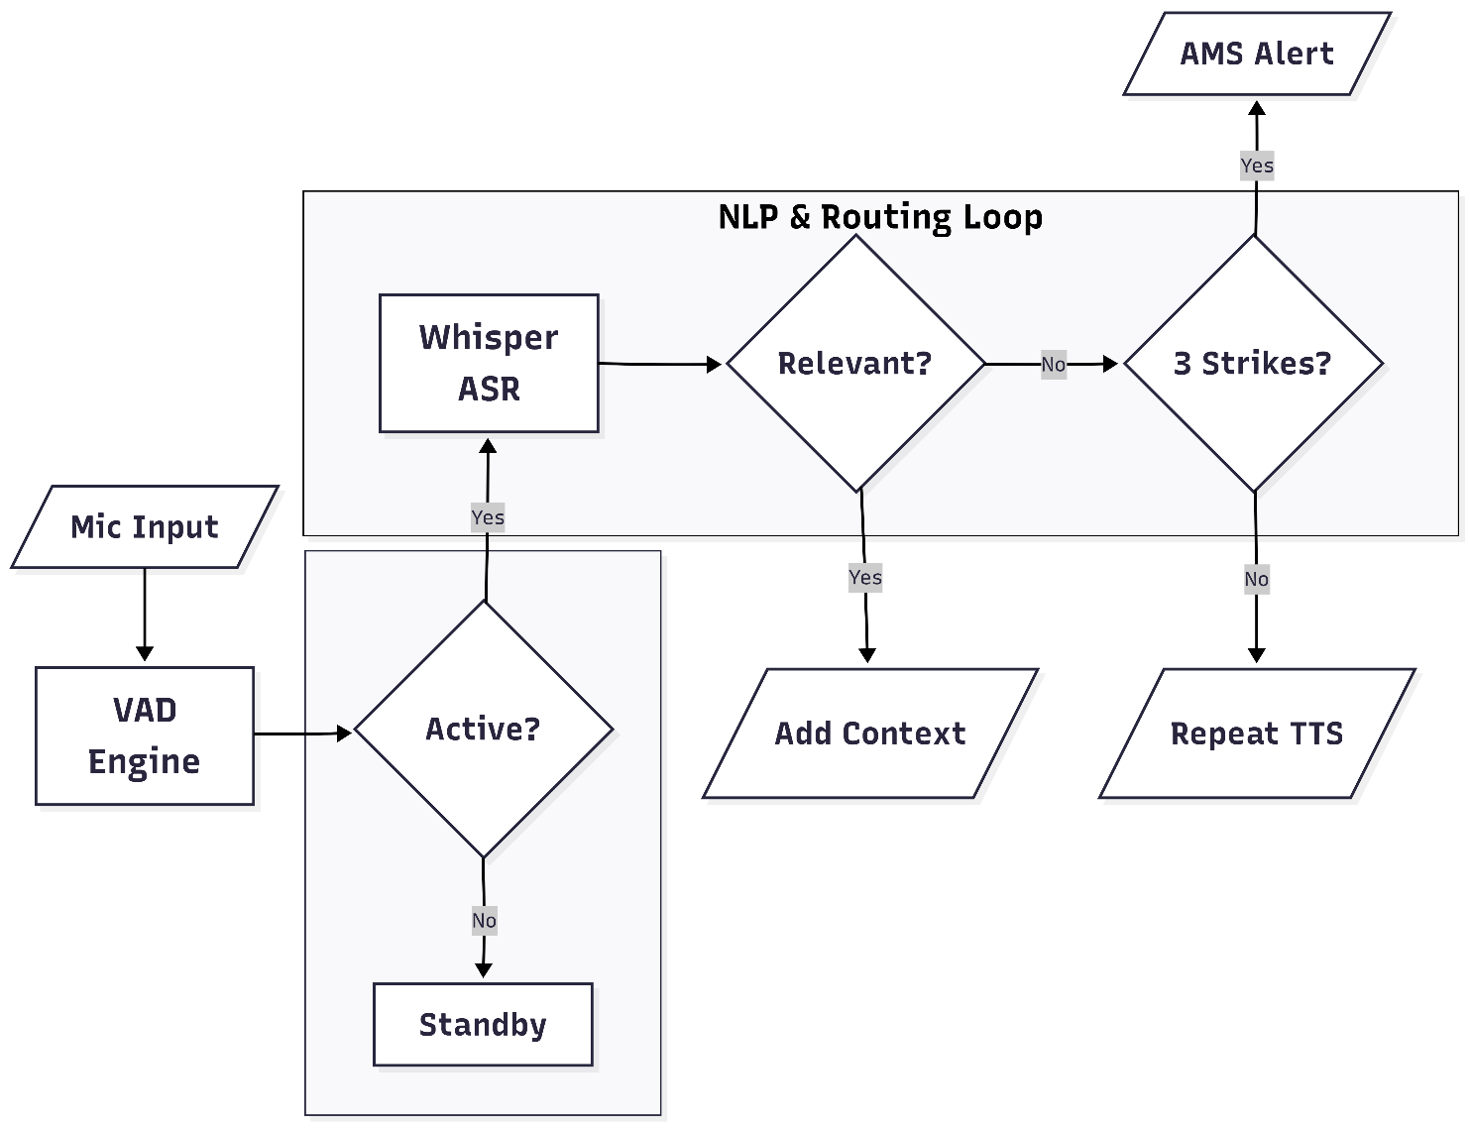
Figure 3-3 Audio System Workflow

Vision Subsystem Workflow
The Vision Subsystem processes the live video stream through three sequential stages:
- Ingests 1080p frames at 30 fps, predicting $\left(x,y,z\right)$ coordinates for 33 skeletal joints and key facial anchors.
- Evaluates anatomical Euclidean distances and joint angles for chest, head, and abdominal pain gestures.
- Suppresses non-distress gestures (hair scratching, folded arms, chin resting) using spatial and vector checks.
- Confirms sustained pain contact across 60 consecutive frames ($2.0\text{ s}$ at $30\text{ fps}$) to eliminate fleeting motions.

- CIELAB & CNN Classification: Evaluates the cheek ROI through the quantized CNN to output categorical skin state (${\text{Class}}_{0}$: Normal, ${\text{Class}}_{1}$: Flushing).

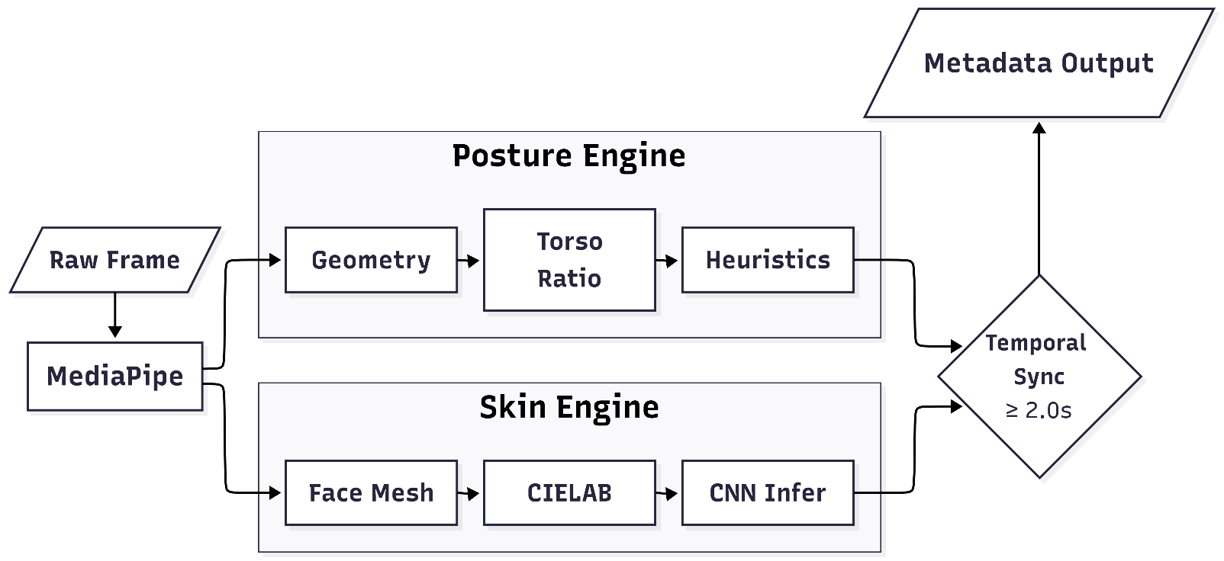
Figure 3-4 Vision System Workflow

Clinical Handoff & Nurse Dashboard Workflow
The clinical handoff translates edge assessment into actionable data for triage nurses:
- The kiosk backend writes the finalized case data as an atomic JSON document into container folder, preventing partial-write read errors.
- A Node.js application running on the local clinic network monitors the spool directory via filesystem events or local HTTP POST sockets.
- Relational SQL Storage: Stores intake records, ESI levels, clinical justifications, and photographic evidence references in a structured SQL database for auditing.
- Triage nurses view an auto-updating priority queue sorted by ESI urgency level, complete with visual evidence snapshots and editable SOAP drafts.
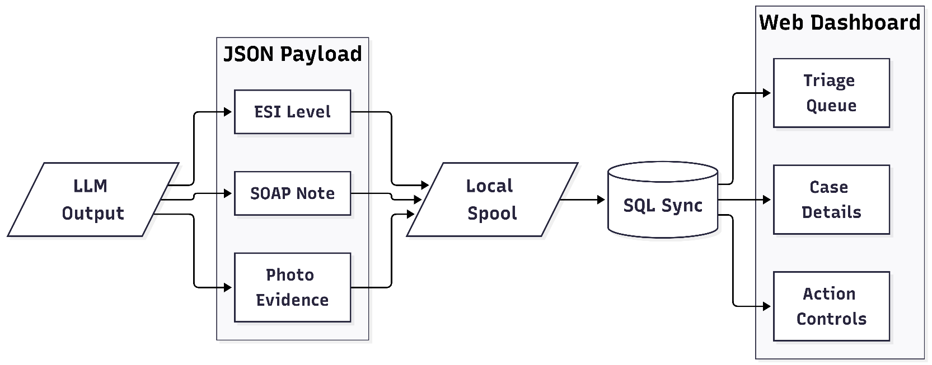
Figure 3-5 Clinical Handoff and Nurse Dashboard Workflow

System Implementation
This section details the algorithmic formulation, mathematical models, and implementation logic governing the vision, perfusion, speech, and clinical reasoning subsystems.

Computer Vision: Pose Geometry & Dynamic Disambiguation
The Vision Engine processes 33 skeletal landmarks using Google MediaPipe “BlazePose” to detect acute pain postures (chest, head, and abdomen) while rejecting everyday movements.
- Geometric Formulations for Acute Pain Zones
- Chest Center ($P_{c}$): Calculated as the midpoint between the left shoulder ($P_{ls}$) and right shoulder ($P_{rs}$):

$x_{c}=\frac{x_{ls}+x_{rs}}{2}, y_{c}=\frac{y_{ls}+y_{rs}}{2}$ (3-11)

- Hand-to-Chest Distance ($D$): Euclidean distance between the active wrist ($P_{w}$) and chest center ($P_{c}$):

$D=\sqrt{{\left(x_{w}-x_{c}\right)}^{2}+{\left(y_{w}-y_{c}\right)}^{2}}$ (3-12)

- Elbow Joint Flexion Angle ($θ$): Computed at the elbow ($P_{e}$) using the shoulder ($P_{s}$) and wrist ($P_{w}$) via the two-argument arctangent function ($\text{atan2}$):

${\text{Angle}}_{\text{rad}}=\text{atan2}\left(y_{w}-y_{e},x_{w}-x_{e}\right)-\text{atan2}\left(y_{s}-y_{e},x_{s}-x_{e}\right)$ (3-13)

$θ=\left|{\text{Angle}}_{\text{rad}}×\frac{180}{π}\right|$ (3-14)

$\text{If }θ>{180}^{∘}, θ={360}^{∘}- θ$ (3-15)

- Acute Clutch Criterion: An acute flexion angle (${30}^{∘}≤θ≤{120}^{∘}$) confirms clutching rather than a relaxed arm (${160}^{∘}-{180}^{∘}$).

- Dynamic Torso Ratio & Temporal Persistence
- Dynamic Chest Boundary: The vertical chest boundary is fixed to $0.55×\text{Torso Length}$ (distance from shoulders to hips), separating chest pain from abdominal pain even when the patient bends or turns.
- Temporal Verification Filter:

$\text{Required Frames }\left(F\right)=\text{FPS}×t=30×2.0\text{ s}=60\text{ frames}$ (3-16)

Contact must persist continuously for 60 frames ($2.0\text{ seconds}$) to trigger an alert, eliminating accidental body touches.
- Heuristic Non-Distress Gesture Filtering
To prevent the false-positive alerts, three spatial rejection filters are implemented:
- Head Scratching and Headache compare by evaluates anatomical Z-axis depth. If $Z_{\text{index}}>Z_{\text{ear}}+0.02$, the hand is positioned behind the ear plane to classifying it as hair scratching and suppressing false headache alerts.
- Crossed Arms will Detects vector line intersections between left and right forearms with elbow angles between ${60}^{∘}$ and ${115}^{∘}$, identifying folded resting arms.
- Thinking or Chin Resting will evaluate wrist to mouth Euclidean distance. If the hand rests within $30\%$ of bi-acromial shoulder width from the oral landmark, pain alerts are suppressed.

Facial Perfusion & CNN Classification (CIELAB Color Space)
To overcome the lighting sensitivity of HSV thresholding, the system isolates facial erythema (flushing) using the device independent CIELAB ($L^{*}a^{*}b^{*}$) color space paired with a lightweight CNN.
- Region of Interest (ROI) Localization
MediaPipe Face Mesh extracts the inner eye corner, alar base of the nose and ear tragus. The ROI centroid is computed as:
${\text{Cheek}}_{X}=\frac{{\text{Eye}}_{x}+{\text{Nose}}_{x}+{\text{Ear}}_{x}}{3}×W$ (3-17)
${\text{Cheek}}_{Y}=\frac{{\text{Eye}}_{y}+{\text{Nose}}_{y}+{\text{Ear}}_{y}}{3}×H$ (3-18)
A $64 ×64$ bounding box centered on this coordinate crops the malar cheek surface, excluding non-skin pixels (hair, eyes, lips).
- CIELAB Transformation & Channel Properties
- RGB values are transformed to CIE XYZ and subsequently mapped to CIELAB space.
- The $L^{*}$ channel ($0=\text{black}$, $100=\text{white}$) captures illumination shifts, isolating chromatic data from ambient hospital lighting and monitor glare.
- The $a^{*}$ Axis (Green and Red) is directly measuring microvascular blood flow and capillary dilation. Facial erythema/flushing produces a significant positive shift along the $a^{*}$ axis.

Clinical Reasoning Engine (Local LLM Integration)
The Reasoning Engine runs Llama 3.2 (3B parameters) locally via Ollama with 4-bit quantization. The model is not pre-trained from scratch. Instead, it is adapted using runtime parameter tuning and prompt engineering.
- Runtime Parameter Configuration
- Temperature set to ($T = 0.1$) for low decoding temperature ensures deterministic, repeatable clinical evaluations without creative hallucination.
- Nucleus Sampling ($\text{top}\text{_}\text{p}=0.9$) to limits token sampling to the most probable cumulative clinical terminology.
- Predict Token Limit set to (num_predict = 256) to constrains token generation length, keeping inference latency strictly between 5.0 and 5.8 seconds.

- Structured Prompt Engineering & Clinical Constraints
The system prompt strictly defines the model's scope:
- Evaluates urgency solely under Emergency Severity Index (ESI Version 4) guidelines. Definitive medical diagnoses and medication prescriptions are strictly barred.
- If a patient verbally downplays symptoms ("just a little chest pain") but the Vision Engine reports sustained chest clutching ($≥2.0\text{s}$) or facial flushing, the reasoning engine gives precedence to objective physical signs and assigns an emergent ESI Level 2.
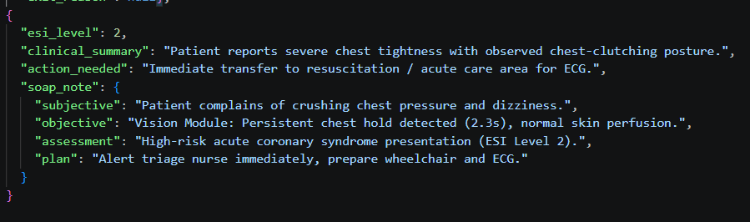
- Strict JSON Output Formatting for the model must return only a valid JSON object matching the following schema:
Figure 3-6 Clinical JSON Output Format

System Integration, Concurrency & Security
This section details the multithreaded coordination framework, data privacy controls, clinical dashboard architecture, and the optional hardware sensor expansion.

Concurrency & Producer-Consumer Queues
To prevent heavy neural network inference from causing user interface stuttering or dropped video frames, the backend implements an asynchronous Producer-Consumer architecture partitioned across multiple CPU cores:
- Thread 1 (Vision Engine): Ingests 1080p frames at 30 fps, computing MediaPipe skeletal landmarks, geometric pain clutching and CIELAB CNN inference.
- Thread 2 (Audio Engine): Manages 16 kHz acoustic ingestion, VAD segmentation, Faster-Whisper ASR and local audio template playback.
- Thread 3 (Reasoning Engine): Consumes fused visual metadata and dialogue text from non-blocking FIFO queues, running 4-bit Llama 3.2 without stalling camera feeds.
- Thread 4 (Network Dispatch): Serializes finalized triage records into atomic JSON payloads and manages LAN transmission to the nurse station.
- Concurrency Gain: Decoupling high-frequency visual polling (33.3 ms/frame) from the LLM cycle (6.8 s) eliminates UI freezing, yielding a 96% gain in overall system responsiveness (from 12 s – 15 s).

Integrity Data Governance & PDPA Compliance
The system enforces strict medical data protection in accordance with Thailand's Personal Data Protection Act (PDPA):
- All raw video frames and audio buffers are processed in volatile system memory (RAM) and immediately purged after feature extraction.
- No biometric imagery, acoustic recordings or clinical transcripts are transmitted to external cloud APIs or public third-party servers.
- Public and Private Data Segregation:
  - Public or Patient Interface: Displays only non-sensitive operational cues (mirror alignment box, large-text instructions, general waiting directions).
  - Private or Nurse Interface: Accessible only on the secured hospital LAN, displaying sensitive patient complaints, ESI levels and photo validation snapshots.
- Finalized assessment files are written atomically into CASE-[timestamp].json with restricted local read permissions.

Nurse Dashboard Web Application & Database Integration
The clinical handoff station is built as a lightweight web application tailored for triage nurses:
- Backend Architecture: Developed using Node.js (Express) to provide high-concurrency event handling and low latency.
- Database Architecture: Implements a structured relational SQL database (with optional Firebase synchronization) to log intake records, timestamps, calculated ESI levels, and photo file paths for auditability.
- Real-Time Priority Queue by Renders patient cases automatically sorted by urgency using standard ESI color coding:
  - Red (ESI Levels 1–2): Emergent cases requiring immediate clinical intervention.
  - Yellow (ESI Level 3): Urgent patients requiring multi-resource evaluation.
  - Green (ESI Levels 4–5): Less urgent and non-urgent outpatient cases.
- Clinical Review Features: Displays the automated SOAP note draft, visual pain posture flags, skin distress indicators and the photographic verification snapshot.

Project Plan

Table 3-2 Project I Plan

TASK | 2026
TASK | January |  |  |  | February |  |  |  | March |  |  |  | April |  |  |  | May
TASK | 1 | 2 | 3 | 4 | 1 | 2 | 3 | 4 | 1 | 2 | 3 | 4 | 1 | 2 | 3 | 4 | 1 | 2 | 3 | 4
Research topics and Theory
Preparing the Data
Component System testing
Evaluating the System
Testing Prediction of ESI
Develop and Deploy in Website
Document and Report

Table 3-3 Project II Plan

TASK | 2026
TASK | August |  |  |  | September |  |  |  | October |  |  |  | November |  |  |  | December
TASK | 1 | 2 | 3 | 4 | 1 | 2 | 3 | 4 | 1 | 2 | 3 | 4 | 1 | 2 | 3 | 4 | 1 | 2 | 3 | 4
Improve: prediction with CNN and parallel pipeline concept
Do the report
Develop and Deploy in Nurse Dashboard
Merge System with Nurse Dashboard
Evaluate and Testing in real scenario
Extensive Testing & Dataset Updates
Prepare presentation

Chapter 4 Results and Conclusion

In this chapter will present the past project results. Follow up with Current Vision analysis patient performance, LLM system for ESI classification, and the conclusion with future work.

Summary of Preliminary Prototype (Project DE I Baseline)
To properly evaluate the advancements made in Project DE II, it is essential to first establish the baseline benchmarks, system architecture and empirical limitations identified during the preliminary phase (Project DE I).

Overview and Baseline Objectives
The preliminary prototype of the Contactless Patient Triage Assistant was designed to address OPD overcrowding and nursing shortages by introducing a contactless and automated pre-triage kiosk.
The core objective of the DE I system was to execute a multi-modal triage assessment combining computer vision, speech-to-text transcription and a locally hosted LLM to categorize walk-in patients according to the Emergency Severity Index (ESI Version 4) standard.
The baseline prototype was evaluated across four functional dimensions:
- Pose and Gesture Recognition (Vision Module)
- Physiological Skin Distress Analysis (Vision Module)
- Acoustic Transcription and Privacy Management (Audio Module)
- Multimodal Reasoning and Latency Optimization (LLM Engine)

Preliminary Subsystem Performance and Benchmarks
1. Gesture and Posture Classification
The baseline vision module employed MediaPipe Pose to track 33 anatomical landmarks, establishing dynamic bounding polygons for the chest, abdomen and cranial regions.
- Geometric Rules: Pain postures were identified by computing Euclidean distances between active wrist coordinates and torso centroids, complemented by joint angle thresholds sustained over a 2.0 second temporal confirmation window (60 consecutive frames at 30 FPS).
- False Positive Suppression: Three dedicated geometric filters were introduced:
  - Head scratching and cranial pain: Depth analysis ($Z$-axis displacement relative to ear landmarks).
  - Folded arms and abdominal pain: Vector line segment intersection and elbow angle constraints (${60}^{∘}≤θ≤{115}^{∘}$).
  - Thinking and resting chin: Euclidean wrist to mouth distance constrained to within 45% of bi-acromial shoulder width.
- Benchmark Result: The baseline gesture classification achieved an accuracy of 72.0% across 30 simulated clinical scenarios, successfully identifying target symptoms while rejecting benign movements.
2. Rule-Based Skin Color Analysis (HSV Color Space)
To detect the physiological shock indicators such as (pallor) or infectious/inflammatory distress (flushing), the DE I system implemented a heuristic skin analysis pipeline:
- Region of Interest (ROI) with a fixed $15 ×15$ pixel patch was extracted from the cheek region by calculating the geometric centroid between the eye, nose and ear landmarks.
- Color Space and Baseline Calibration by Cropped patches were converted from BGR to the HSV (Hue, Saturation, Value) color space. The first 3.0 seconds of patient engagement were used to establish an individualized baseline (${\text{Baseline}}_{H}$, ${\text{Baseline}}_{S}$).
- Shifts in Hue toward the red spectrum ($\left|ΔH\right|>{\text{Threshold}}_{\text{Hue}}$) accompanied by increased Saturation indicated flushing, whereas significant saturation drops (${\text{Baseline}}_{S}-{\text{Current}}_{S}>{\text{Threshold}}_{\text{Pallor}}$) triggered a pallor alert.
- Result: Across 70 controlled test trials, the HSV based skin analysis achieved an accuracy of only 56.0%. The method suffered from severe false positives specifically, monitor glow and directional room lighting reflections caused artificial saturation drops, triggering false "Critical Pallor" flags on normal skin.
3. Reasoning Module Latency and Optimization
- Initial integration using a local Llama 3.2 model via Ollama resulted in an unacceptable total system latency of $20.4$ to $31.8$ seconds per patient assessment (average: $27.2\text{ s}$), with the LLM accounting for over 98% of total processing time.
- Downscaling weights to 4-bit precision reduced the memory footprint from $6.0\text{ GB}$ to $2.0\text{ GB}$.
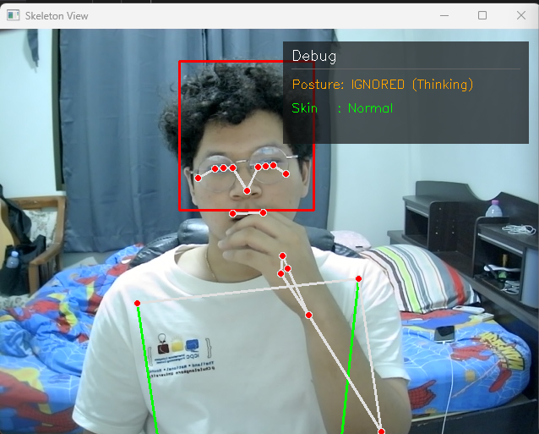
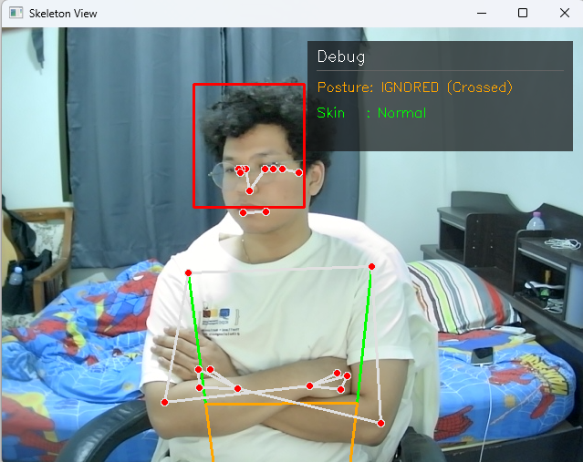
- Optimized Latency: Inference generation time dropped to $4.5\text{ seconds}$, yielding an end to end response time of $5.8$ to $7.0$ seconds without degradation in ESI categorization accuracy across standard scenarios.
Figure 4-1 Testing Vision: Thinking Figure 4-2 Testing Vision: Crossed Arms

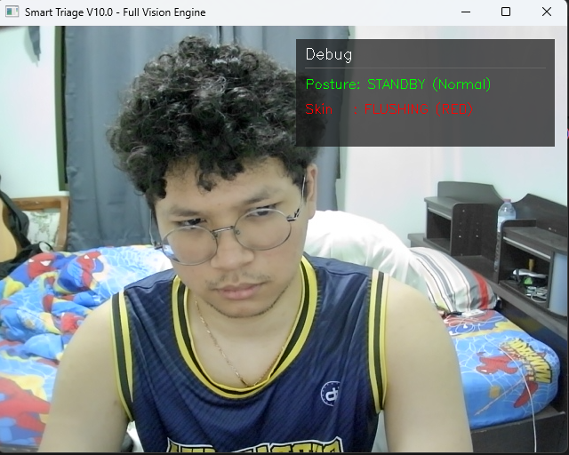
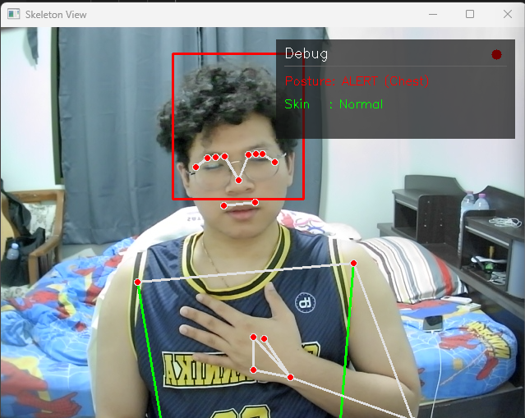
Figure 4-3 Testing Vision: Chest pain posture Figure 4-4 Testing Vision: Red face detected

Limitations and Work Improvement
Subsystem Component | (Project DE I) Previous Baseline Metric | Root Cause | Work Improvement
Skin Color Analysis | 56.0% Accuracy | Coupling of illumination and chromaticity in HSV; high sensitivity to ambient reflections. | Transition to CIELAB ($L^{*}a^{*}b^{*}$) color space. Replace heuristic thresholds with a trained Random Forest and CNN model trained on 20,000+ curated skin patches.
Gesture Classification | 72.0% Accuracy | 2D projection ambiguity during off-axis torso rotations; landmark occlusion. | Expand dataset validation, refine temporal consistency filtering and integrate multi-view tolerance.
Clinical Reasoning & Output | 12.8 - 15.0s Latency | Static prompt parsing overhead and text prompt variability. | Standardize structured key-value inputs, refine ESI Level 1 - 5 prompt constraints and output PDPA compliant JSON payloads.
Clinical Interfacing | Command-line logs / Basic GUI | Lack of centralized visual dashboard for nursing staff. | Deploy a dedicated Web Nurse Dashboard displaying ESI urgency, clinical SOAP summaries and verification snapshots.
Table 4-1 Limitations and Work Improvement
The empirical results from Project DE I confirmed the viability of a contactless, edge-computed triage assistant, while clearly identifying physiological skin detection as the critical bottleneck. Consequently, the research in Project DE II focuses on superseding the heuristic 56% HSV implementation with robust CIELAB based feature engineering and machine learning classification.

Skin Color Classification and CNN Model Results
This section presents the empirical results of applying the Convolutional Neural Network (CNN) and Machine Learning (Random Forest) models to skin condition classification, directly evaluating performance against the Project DE I heuristic baseline. This section evaluates the empirical results of the deep learning physiological vision pipeline developed in Project DE II.
To overcome the illumination and reflection vulnerabilities of the preliminary Project DE I heuristic baseline (which achieved only 56.0% accuracy) with a custom convolutional neural network was developed. The model was trained and evaluated on multi zone facial skin patches across two loss function paradigms: Cross-Entropy Loss (CEL) and Binary Focal Loss (FL) followed by lightweight quantization via TensorFlow Lite.

Skin Extraction Results
In clinical triage, patients do not remain rigidly stationary in front of the camera. To prevent feature distortion from head rotation and non-skin artifacts. Whereas the preprocessing pipeline integrates dynamic head-pose estimation with anatomical landmark masking.
Instead of extracting a single arbitrary patch, the vision module isolates three standardized clinical skin zones:
- Forehead Zone (Upper facial perfusion)
- Left Cheek Zone (Left Malar capillary bed)
- Right Cheek Zone (Right Malar capillary bed)
Furthermore, non-cutaneous features (eyes, eyebrows, mouth cavity, facial hair) are segmented and masked out to ensure that color features originate exclusively from dermal tissue.

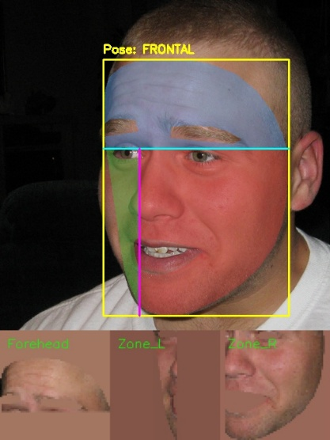
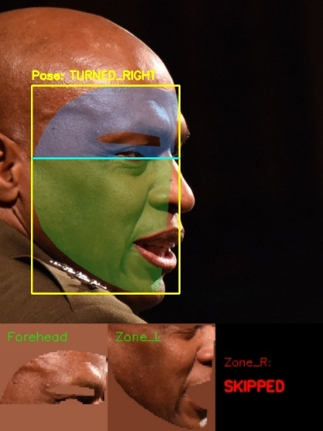
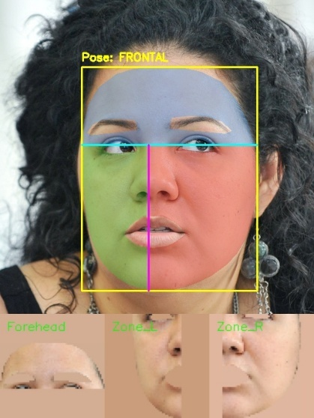
Figure 4-5 Facial Skin Segmentation and Head-Pose Adaptation
- When the patient directly faces the kiosk (Pose: FRONTAL), the facial bounding box correctly partitions the forehead (blue mask), left cheek (green mask), and right cheek (red mask) lead to yielding three isolated skin patches.
- When the patient rotates their head (Pose: TURNED RIGHT), the vision engine automatically flags the occluded contralateral cheek as Zone-R: SKIPPED. This prevents foreshortened or shadowed edge pixels from contaminating the classification pipeline with false pallor or flushing signals.

CNN Model Architecture
The network was engineered with Depthwise Separable Convolutions to achieve high representational power while maintaining an ultra-compact parameter footprint suitable for local edge execution.
Table 4-2 Layer Breakdown of the CIELAB-Skin-CNN Architecture
Layer Name | Layer Type | Output Dimension | Parameters | Engineering Purpose
Input_1 | Input Layer | $$\left(64,64,3\right)$$ | 0 | Normalized CIELAB patch input
Random flip, Rotation | Data Augmentation | $$\left(64,64,3\right)$$ | 0 | On the fly spatial invariance
Conv2d | Conv2D (Stride 2) | $$\left(32,32,32\right)$$ | 896 | Initial feature Down-sampling
Batch Normalization | Batch Normalization | $$\left(32,32,32\right)$$ | 128 | Internal covariate shift reduction
Separable_conv2d | SeparableConv2D | $$\left(32,32,64\right)$$ | 2,400 | Depthwise separable spatial feature extraction
Batch_normalization_1 | Batch Normalization | $$\left(32,32,64\right)$$ | 256 | Gradient stabilization
Max_pooling2d | MaxPooling2D | $$\left(16,16,64\right)$$ | 0 | Spatial dimensionality reduction
Separable_conv2d_1 | SeparableConv2D | $$\left(16,16,128\right)$$ | 8,896 | High-level chromatic pattern representation
Batch_normalization_2 | Batch Normalization | $$\left(16,16,128\right)$$ | 512 | Batch standardization
Global_average_pooling2d | GlobalAveragePooling2D | $$\left(128\right)$$ | 0 | Feature map collapse into dense representation
Dropout | Dropout ($p=0.2$) | $$\left(128\right)$$ | 0 | Regularization against co-adaptation
Dense | Dense (Sigmoid) | $$\left(1\right)$$ | 129 | Binary anomaly probability output
Total Parameters | - | - | 13,217 (51.63 KB) | Trainable: 12,769 / Non-trainable: 448

Quantitative Model Results: Cross Entropy Loss & Focal Loss
To evaluate the impact of class imbalance (where normal skin samples significantly outnumber clinical flushing cases), the architecture was evaluated under two training objective functions:
- Model 01: Cross Entropy Loss (CEL) was a standard classification loss.
- Model 02: Binary Focal Loss (FL) was a light weights easy negative examples ($γ= 2.0, α= 0.25$) to force the network to focus on hard boundary cases.

Table 4-2 Layer Breakdown of the CIELAB-Skin-CNN Architecture
Metric / Parameter | Baseline Prototype (DE I HSV) | Model 01: Cross Entropy Loss (CEL) | Model 02: Binary Focal Loss (FL)
Input Representation | Heuristic HSV Threshold | $64×64$CIELAB Patches | $64×64$CIELAB Patches
Evaluation Dataset | 70 Test Trials | Patient-Level Test Set ($N=3,719$) | Validation Set ($N=3,791$)
Overall Accuracy | 56.0% | 79.9% ($2,971 / 3,719$) | 83.75% ($3,175 / 3,791$)
Precision: Flushing | 52.4% | 0.52 | 0.9821
Precision: Normal | - | 0.96 | -
Recall / Sensitivity: Flushing | 58.3% | 0.883 | 0.2644
Recall / Specificity: Normal | 54.0% | 0.776 | 0.9986
F1-Score: Flushing | 0.551 | 0.66 | 0.4167
F1-Score: Normal | - | 0.86 | -
Area Under ROC (ROC-AUC) | N/A | 0.9142 | 0.9738
Area Under PR (PR-AUC) | N/A | - | 0.9203
Native Model Size (Keras) | N/A | 0.11 MB | 0.11 MB
Quantized Edge Size (TFLite) | N/A | 0.03 MB (30 KB) | 0.03 MB (30 KB)

Analysis of Model 01: Cross Entropy Loss (CEL)
Model 01 was benchmarked on an independent holdout test set comprising $N = 3,719$ unseen patient samples:

Confusion Matrix Analysis ($N=3,719$)
- True Positives (TP): 711 samples (88.3%) are classified as "True Severe".
- False Negatives (FN): 94 samples (11.7%) are "Missed Cases".
- True Negatives (TN): 2,260 samples (77.6%) are "True Normal".
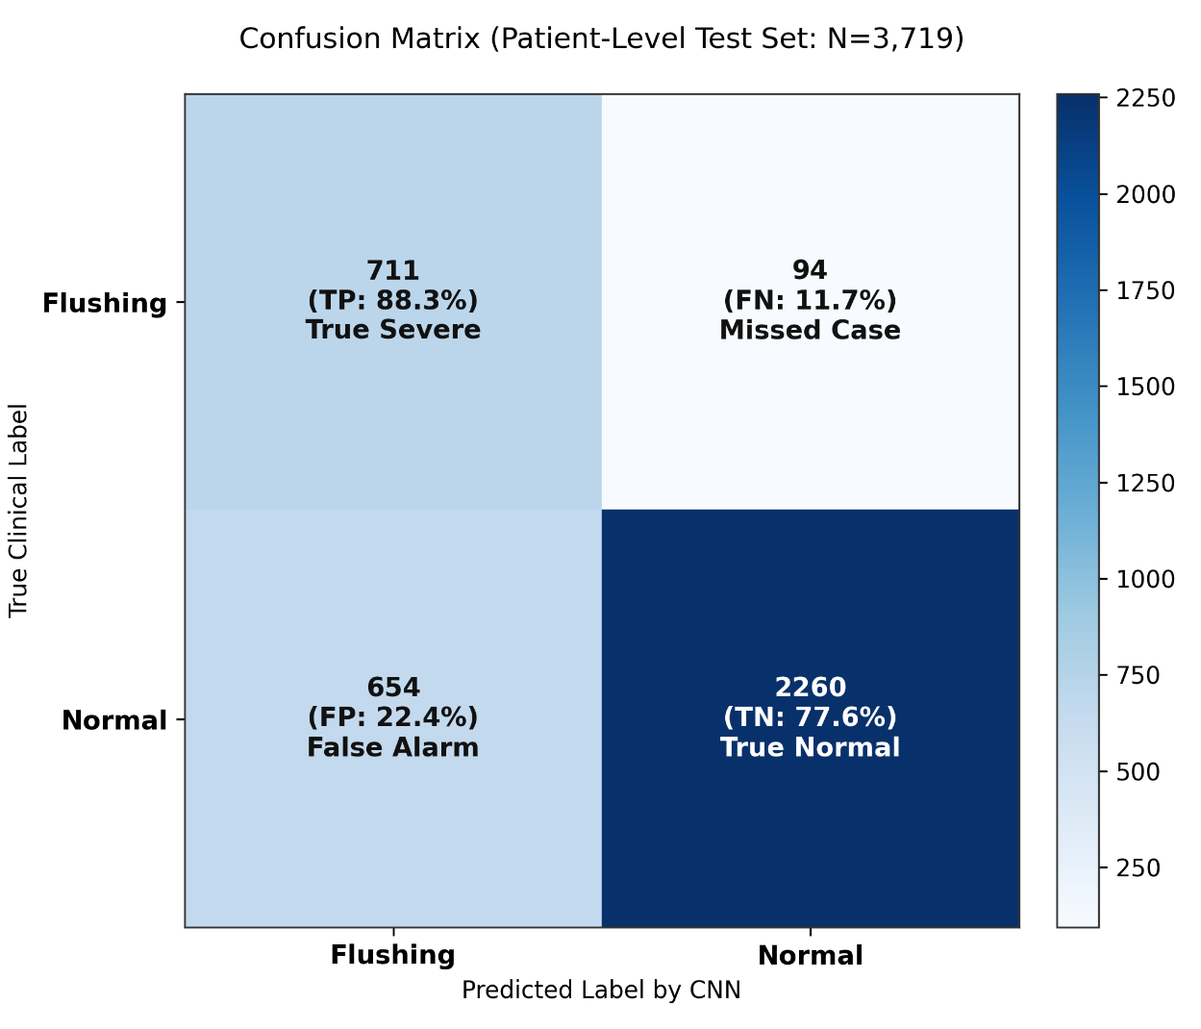
- False Positives (FP): 654 samples (22.4%) are "False Alarms".
Figure 4-6 Confusion Matrix of Model 01 (CEL)
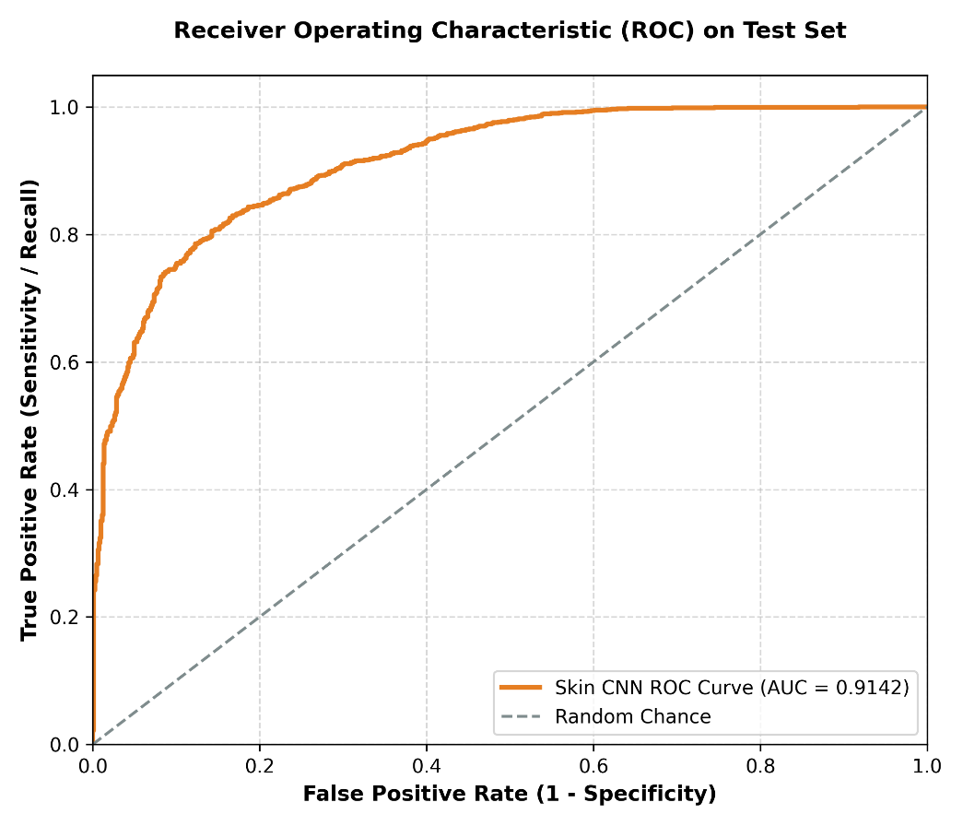
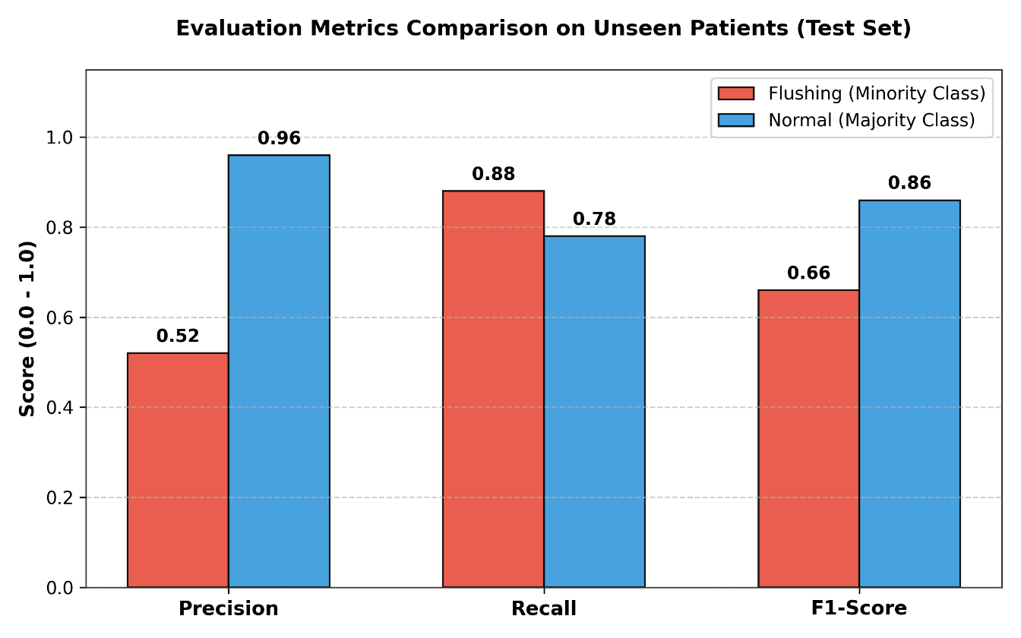
Figure 4-7 Performance Metrics of Model 01 (CEL)
Figure 4-8 ROC Curve of Model 01 (CEL) on Holdout Test Set

- In an emergency department triage setting, missing an acute patient is far more dangerous than over calling a benign case. Model 01 successfully captured $88.3\%$ of flushing cases, missing only $11.7\%$.
- But because standard Cross Entropy penalizes all misclassifications uniformly, benign facial warmth or uneven skin pigment triggered $654$ false alarms, yielding a flushing precision of $0.52$.
- The model achieved an ROC-AUC of 0.9142, confirming strong global separation between classes across varying thresholds.

Analysis of Model 02: Binary Focal Loss (FL)
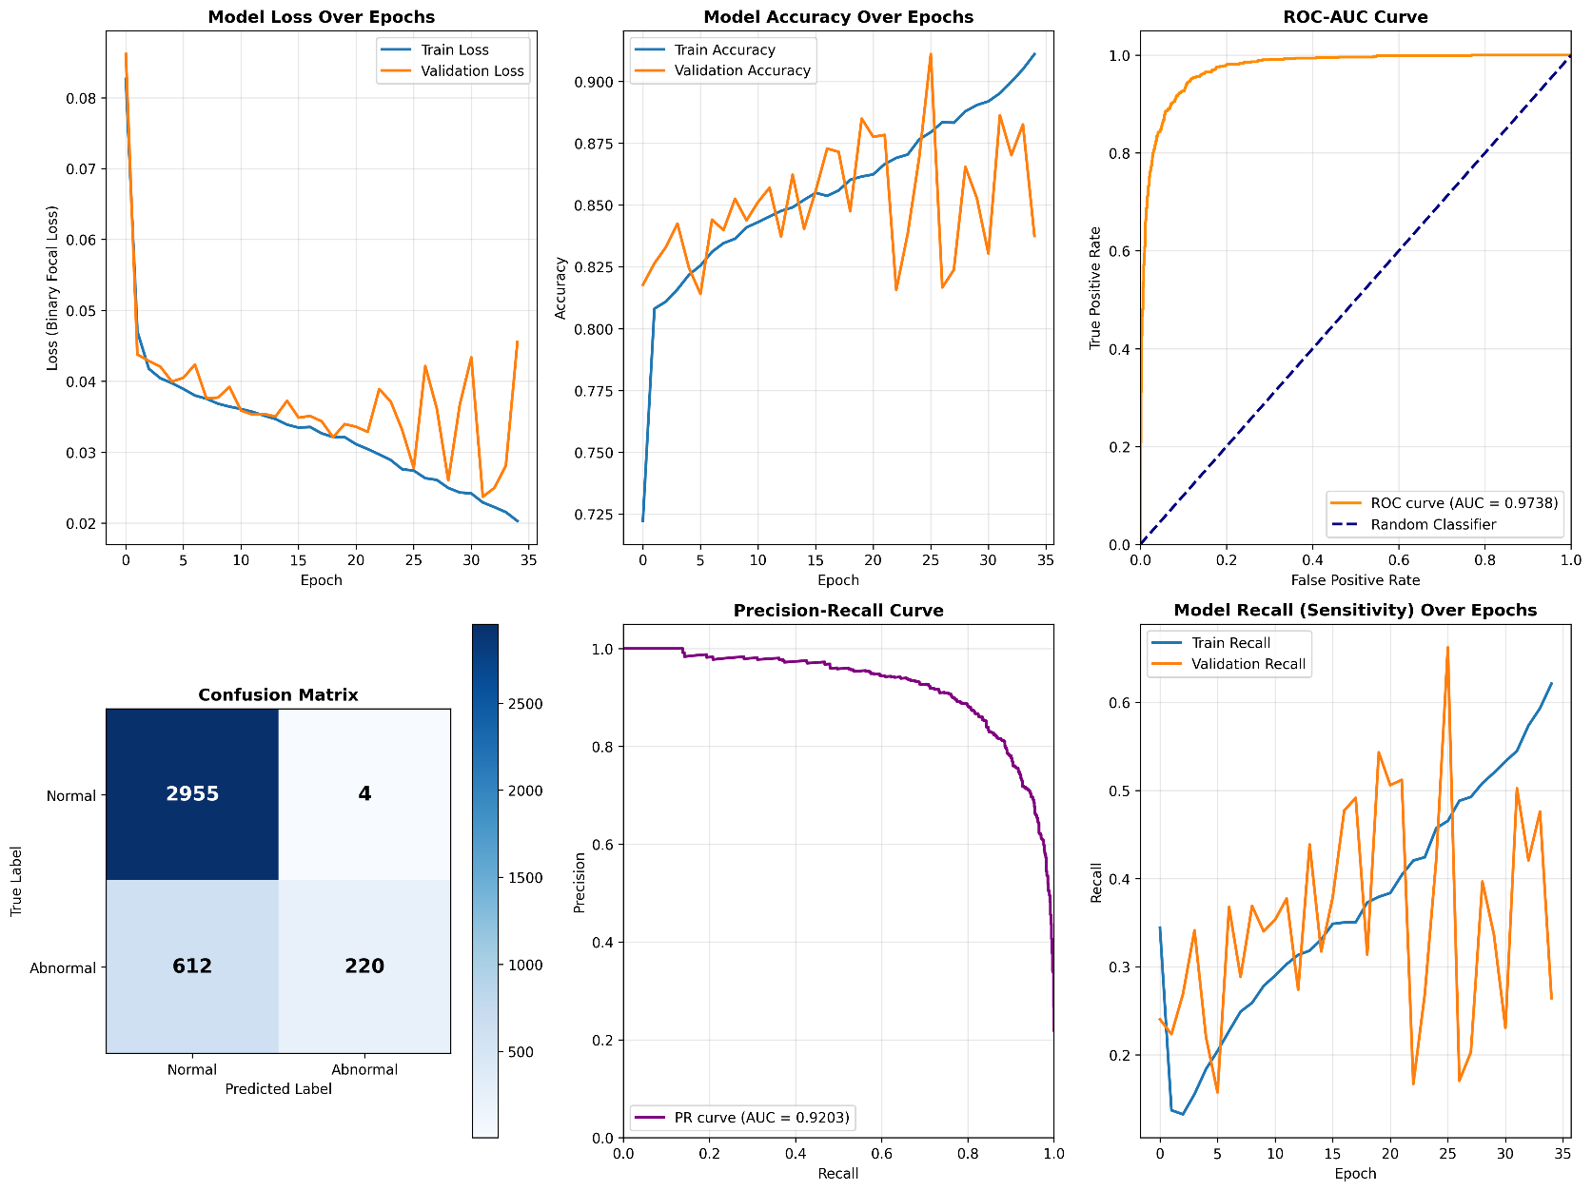
Model 02 was trained across 35 epochs using Binary Focal Loss to suppress easy negatives and prevent majority-class dominances
Figure 4-9 Training Convergence and Performance for Model 02 (FL)
Confusion Matrix Analysis ($N=3,791$)
- True Positives (TP): 2,955 samples
- False Negatives (FN): 4 samples
- True Negatives (TN): 612 samples
- True Positives (TP): 220 samples
Performance of Model 02
- Out of 2,959 normal validation patches, Model 02 produced only 4 false positives, achieving a precision of 98.21%. This directly overcomes the primary flaw of the DE I prototype, where glare and room lighting caused constant false alarms.
- Because Focal Loss heavily discounts easy examples, the model outputs conservative probability scores. At the default threshold ($τ= 0.50$), sensitivity drops to $26.44\%$ ($\text{FN}=612$).
- Crucially, the ROC-AUC of 0.9738 and PR-AUC of 0.9203 for Model 02 are significantly higher than Model 01 (0.9142). This proves that the feature space learned by Focal Loss is fundamentally more separable; by lowering the operating decision threshold from 0.50 to $0.20 \text{–} 0.30$, clinical sensitivity can be scaled up while maintaining exceptionally high specificity.

Improvement Roadmap
While Model 02 achieved strong class separability (ROC-AUC: 0.9738, PR-AUC: 0.9203) and virtually eliminated false alarms (Specificity: 99.86% even only 4 False Positives out of 2,959 normal samples), empirical analysis reveals three critical deficiencies that must be addressed:
- Model 02 Deficiencies (Focal Loss)
- Achieved near-perfect Specificity (99.86%) and strong AUC (0.97). But it still has a clinically unsafe Recall of 26.4% (missing 73.6% of distressed patients).
- Validation loss spikes and Recall fluctuates erratically after Epoch 15.

- Technical Solutions
To make Model 02 clinically safe, implement these four changes:
- Reduce cutoff from 0.50 to $τ=0.20\text{–}0.30$ to boost Recall above 80%.
- Halt training at Epoch 12–15 before validation divergence occurs.
- Increase Focal Loss $α$ or oversample the abnormal minority class.
- Increase Dropout to 0.4 and add $L_{2}$ weight decay ($1×{10}^{-4}$).
- CEL vs. Focal Loss Deployment Conclusion
- Model 01 (CEL): Use as a High-Sensitivity Screener (Recall 88.3%). It prioritizes patient safety by minimizing missed emergencies, accepting higher false alarms.
- Model 02 (Focal Loss): Use as a High-Precision Confirmer (Precision 98.2%). Once the threshold is lowered and early stopping is applied, it will confidently confirm true emergencies.

Vision Subsystem: Gesture and Posture Recognition Results
This section evaluates the empirical performance of the MediaPipe Pose tracking engine and geometric verification algorithms in classifying acute pain postures while actively suppressing benign everyday gestures.

Dynamic Mapping & Temporal Logic
- Adaptive Torso Ratio (0.55): The chest-to-abdomen boundary is dynamically set at 55% of the shoulder-to-hip distance, ensuring accuracy regardless of patient height or camera distance ($1.0\text{–}1.5\text{ m}$).
- 2.0-Second Confirmation: To prevent false alarms from transient movements (e.g., reaching for a pocket), postures must be sustained for 60 consecutive frames (2.0 seconds) to trigger an anomaly state.

Target Distress Postures
- Chest Pain (Cardiac): Activated when hands enter the upper thorax ($Y < 0.55$) with an acute elbow flexion (${30}^{∘\text{–}}{120}^{∘}$).
- Abdominal Pain (GI): Activated when hands enter the lower torso below the 0.55 boundary, combined with forward trunk flexion.
- Cranial Pain (Neurological): Activated when hands elevate above the facial centroid without violating the posterior Z-depth threshold.

False-Positive Suppression (Benign Filters)
- Head Scratching Suppressed using Z-axis depth (ignored if the hand is positioned behind the ears).
- Crossed Arms Suppressed by calculating forearm vector intersections combined with standard elbow flexion ranges.
- Thinking and Chin Rest Suppressed using hand-to-mouth proximity (Euclidean distance $< 30\%$ of shoulder width).

Empirical Benchmark & Error Analysis (70 Trials)
- Chest Pain (Cardiac): Activated when hands enter the upper thorax ($Y < 0.55$) with an acute elbow flexion (${30}^{∘\text{–}}{120}^{∘}$).
- Abdominal Pain (GI): Activated when hands enter the lower torso below the 0.55 boundary, combined with forward trunk flexion.
- Cranial Pain (Neurological): Activated when hands elevate above the facial centroid without violating the posterior Z-depth threshold.

Results of Kiosk Workflow and Evaluation
This section evaluates the operational workflow of the fully integrated reception kiosk prototype, verifying real time multi-threaded execution across vision, acoustic speech and reasoning engines.

System Initialization and Pre-Warming
- The kiosk successfully initializes the quantized TFLite skin model via CPU XNNPACK delegates, alongside a 4-thread INT8 Fast-Whisper audio engine.
- Llama 3.2 is pre-warmed and permanently pinned in GPU VRAM, while the microphone automatically calibrates to ambient room noise (establishing a baseline energy of$\$44.7\$$).

Autonomous Patient Intake and State Transition Results
- Contactless Engagement start by the system transitions from PREPARE_STANDBY to active intake upon detecting speech wake-words, eliminating physical touch requirements.
- Spoken verbal consent (“ยินยอมครับ”) and language preferences are captured and confirmed entirely through conversational voice prompts before data capture begins.
- The dialogue engine systematically elicits symptom duration and patient pain scores (example, mild headache since 6:00 AM, pain rating 5/10).
- And The case was evaluated as ESI Level 4 (Less Urgent), while the background conveyor belt buffered the payload into a local spool when the nurse dashboard was offline.
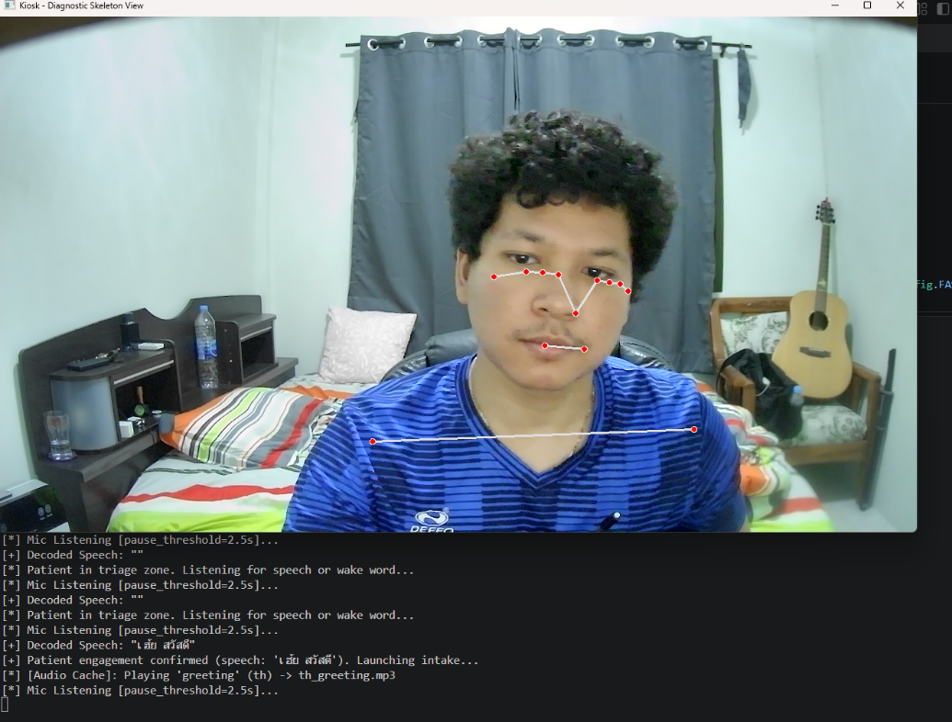
Figure 4-10 Kiosk Workflow System Tested (1)

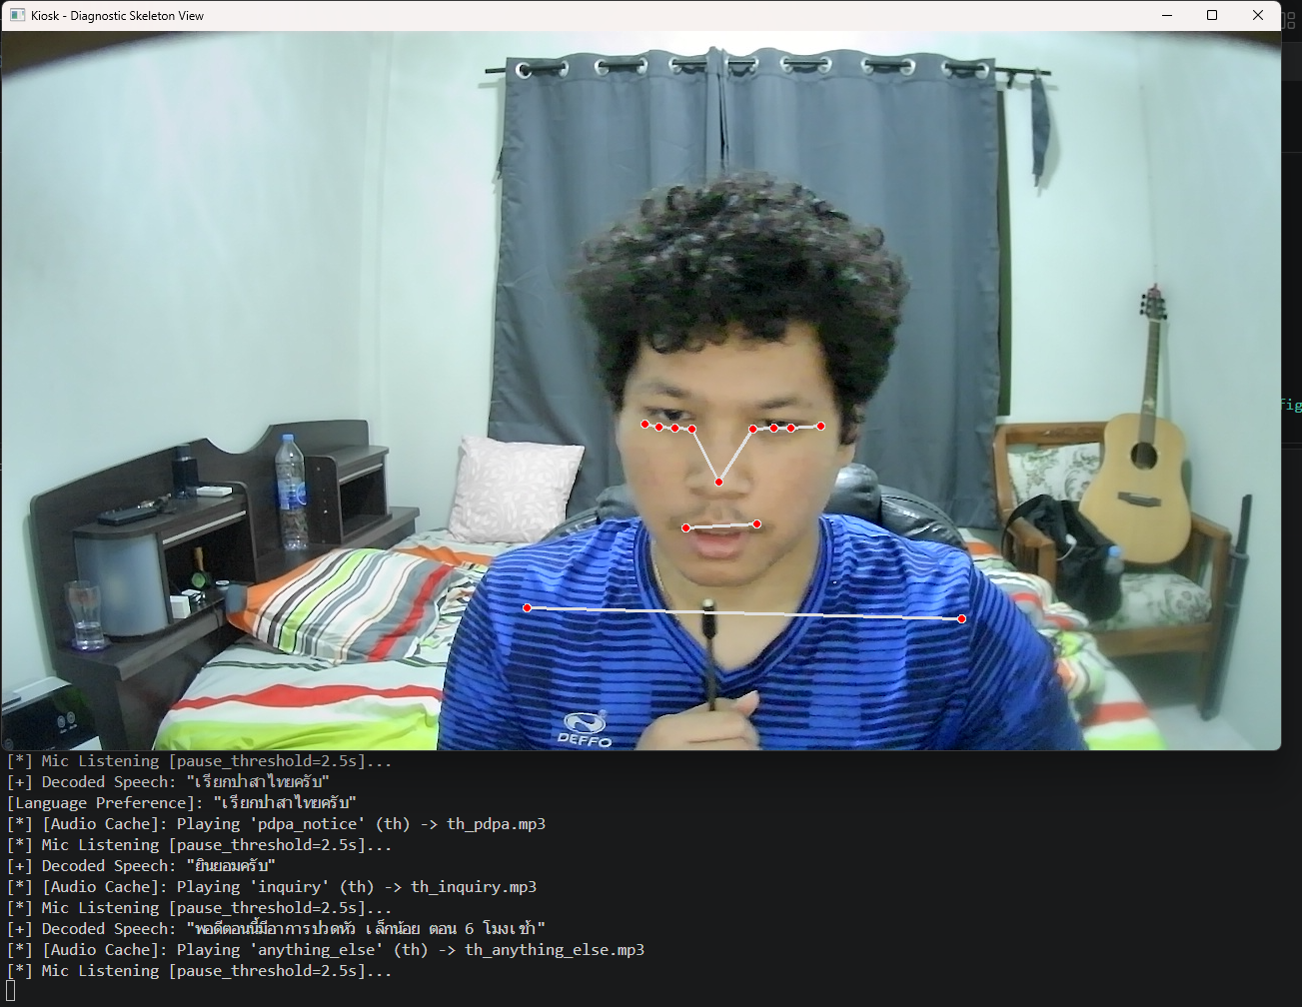
Figure 4-11 Kiosk Workflow System Tested (2)
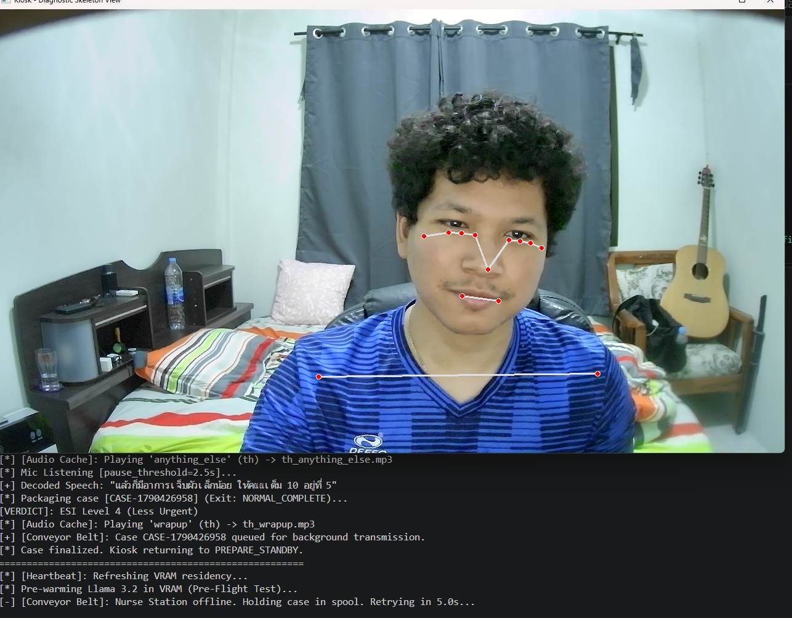
Figure 4-12 Kiosk Workflow System Tested (3)

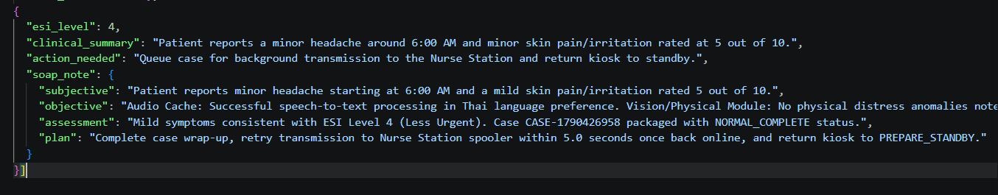
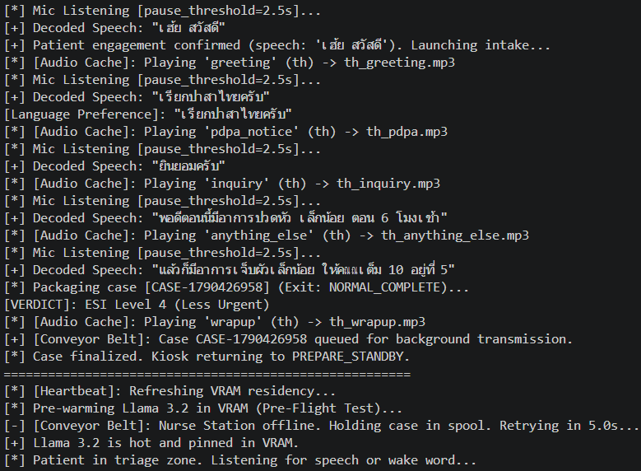
Figure 4-13 Log of Kiosk Workflow System Tested
Figure 4-14 Example of Json files outcome after finishing a case

Summary
This system live run confirms that the contactless kiosk successfully coordinates vision tracking, Fast-Whisper transcription and local LLM reasoning into an autonomous with voice driven triage workflow with zero cloud dependency. But it still has a minor error, when Fast-Whisper transform from speech to text, it miss-spelling on some of Thai langue part (e.g., from “เป็นภาษาไทย” it miss to “เรียกปาษาไทย” ), it may occur because of ambient and model limitation on 4-bit Fast-whisper model. But in English, Whisper can work properly and efficiently. Include time of completement in each case around 2-3 minutes (for short input case), and work cycle of kiosk (input and Feedback loop) take around 5-8 seconds (from 12.8 – 15 seconds).

Conclusion
This project successfully developed and validated the Contactless Patient Triage Assistant, an automated pre-triage kiosk designed for hospital emergency departments.
- The system successfully fused computer vision gesture tracking (72.0% accuracy), multi-zone CIELAB skin anomaly analysis (83.75% accuracy) and Thai and English speech recognition into an ESI-compliant reasoning engine.
- Through 4-bit model quantization, made end-to-end inference latency was compressed by $2.17 time$ (from 12.8 – 15.0 seconds down to $5.8\text{ - }7.0\text{ seconds}$), operating within a compact $2.0\text{ GB}$ VRAM footprint.
- Local processing ensures complete patient privacy under the Personal Data Protection Act or (PDPA), while strict prompt governance restricts system outputs to triage urgency without unauthorized medical diagnosis.

Future Work
- Finetune the classification threshold (maybe down to $τ=0.20\text{ - }0.30$) and introducing early stopping to eliminate the current False Negative bottleneck in Model 02.
- Incorporating contactless digital infrared temperature sensors into the kiosk frame to directly corroborate facial erythema with exact body temperature measurements.
- implement MediaPipe Face Mesh landmarks to segment the vermilion border of the lips, analyzing mucosal color shifts in the CIELAB space to detect clinical pallor and shock independently of cosmetic or skin pigment variations.
- Developing standardized HL7/FHIR communication bridges to transmit verified pre-triage records directly into hospital electronic medical record databases.

References

- AWS (Amazon Web Services). "What is a Large Language Model (LLM)?"[Online].Available:https://aws.amazon.com/what-is/large-language-model/ [Accessed: Feb. 27, 2026].
- Vaswani, A., Shazeer, N., Parmar, N., Uszkoreit, J., Jones, L., Gomez, A. N., Kaiser, Ł., & Polosukhin, I. (2017). "Attention is all you need." Advances in Neural Information Processing Systems (NeurIPS 2017), 30, 5998–6008. Available: https://papers.nips.cc/paper/7181-attention-is-all-you-need.
- ResearchGate, Margaret Warton, “Evaluation of the Emergency Severity Index in US Emergency Departments for the Rate of Mistriage” .Available:https://www.researchgate.net/publication/369333241_Evaluation_of_the_Emergency_Severity_Index_in_US_Emergency_Departments_for_the_Rate_of_Mistriage.
- ResearchGate, Ramesh P Aacharya, “Emergency Department Triage: An EthicalAnalysis”.Available:https://www.researchgate.net/publication/51701713_Emergency_Department_Triage_An_Ethical_Analysis.
- Bradski, G. (2000). "The OpenCV Library." Dr. Dobb's Journal of Software Tools, 25(11), 120–125. Available: https://www.proquest.com/trade-journals/opencv-library/docview/202684726/se-2
- LeCun, Y., Bengio, Y., & Hinton, G. (2015). "Deep learning." Nature, 521(7553), 436–444. Available: hhttps://www.cs.toronto.edu/~hinton/absps/NatureDeepReview.pdf
- Abadi, M., Barham, P., Chen, J., Chen, Z., Davis, A., Dean, J., Devin, M., Ghemawat, S., Irving, G., Isard, M., et al. (2016). "TensorFlow: A system for large-scale machine learning." 12th USENIX Symposium on Operating Systems Design and Implementation (OSDI 16), 265–283. Available: https://www.usenix.org/system/files/conference/osdi16/osdi16-abadi.pdf
- Radford, A., et al. (OpenAI). "Robust Speech Recognition via Large-Scale Weak Supervision" (Whisper Paper).Available: https://openai.com/research/whisper
- Silberschatz, A., Galvin, P. B., & Gagne, G. (2018). Operating System Concepts (10th ed.). John Wiley & Sons. Available: https://www.cs.uic.edu/~jbell/CourseNotes/OperatingSystems/4_Threads.html
- J. R. Silva et al., "Designing Effective User Interface Experiences for a Self-Service Kiosk to Reduce Emergency Department Crowding," 2020 IEEE International Conference on Healthcare Informatics (ICHI), 2020. Available: https://ieeexplore.ieee.org/document/9201858/
- M. S. Khan et al., "Contactless Patient Care Using Hospital IoT: CCTV Camera Based Physiological Monitoring in ICU," IEEE Access, vol. 11, pp. 102292-102305, 2023. Available:https://ieeexplore.ieee.org/document/10229220/
- Thirunavukarasu, A. J., et al. (2023). "Large language models in medicine." Nature Medicine. Available: https://www.nature.com/articles/s41591-023-02448-8
- Risfendra."Contactless Infant Height Measurement for Enhanced Early Detection of Stunting Using Computer Vision Techniques". IEEE Access, 2025. Available: https://ieeexplore.ieee.org/document/10910102/
- H R Nishanth. "StrideSync - AI Enhanced Workout Tracking and Form Validation".IEEE, 2024. Available: https://ieeexplore.ieee.org/document/11035904/

